MODULE 2 :- LINUX
LINUX FUNDAMENTALS
SUBMITTED BY :- CHANDAN YADAV KS
SUBMITTED TO :- VIKUL
DATE OF SUBMISSION :- 26-05-2025

1. L1 - In EC2 Ubuntu Instance Create a new user and SSH Key pair with an authorized key
STEP1 :-Create Two EC2 Ubuntu Instance User1 and User2
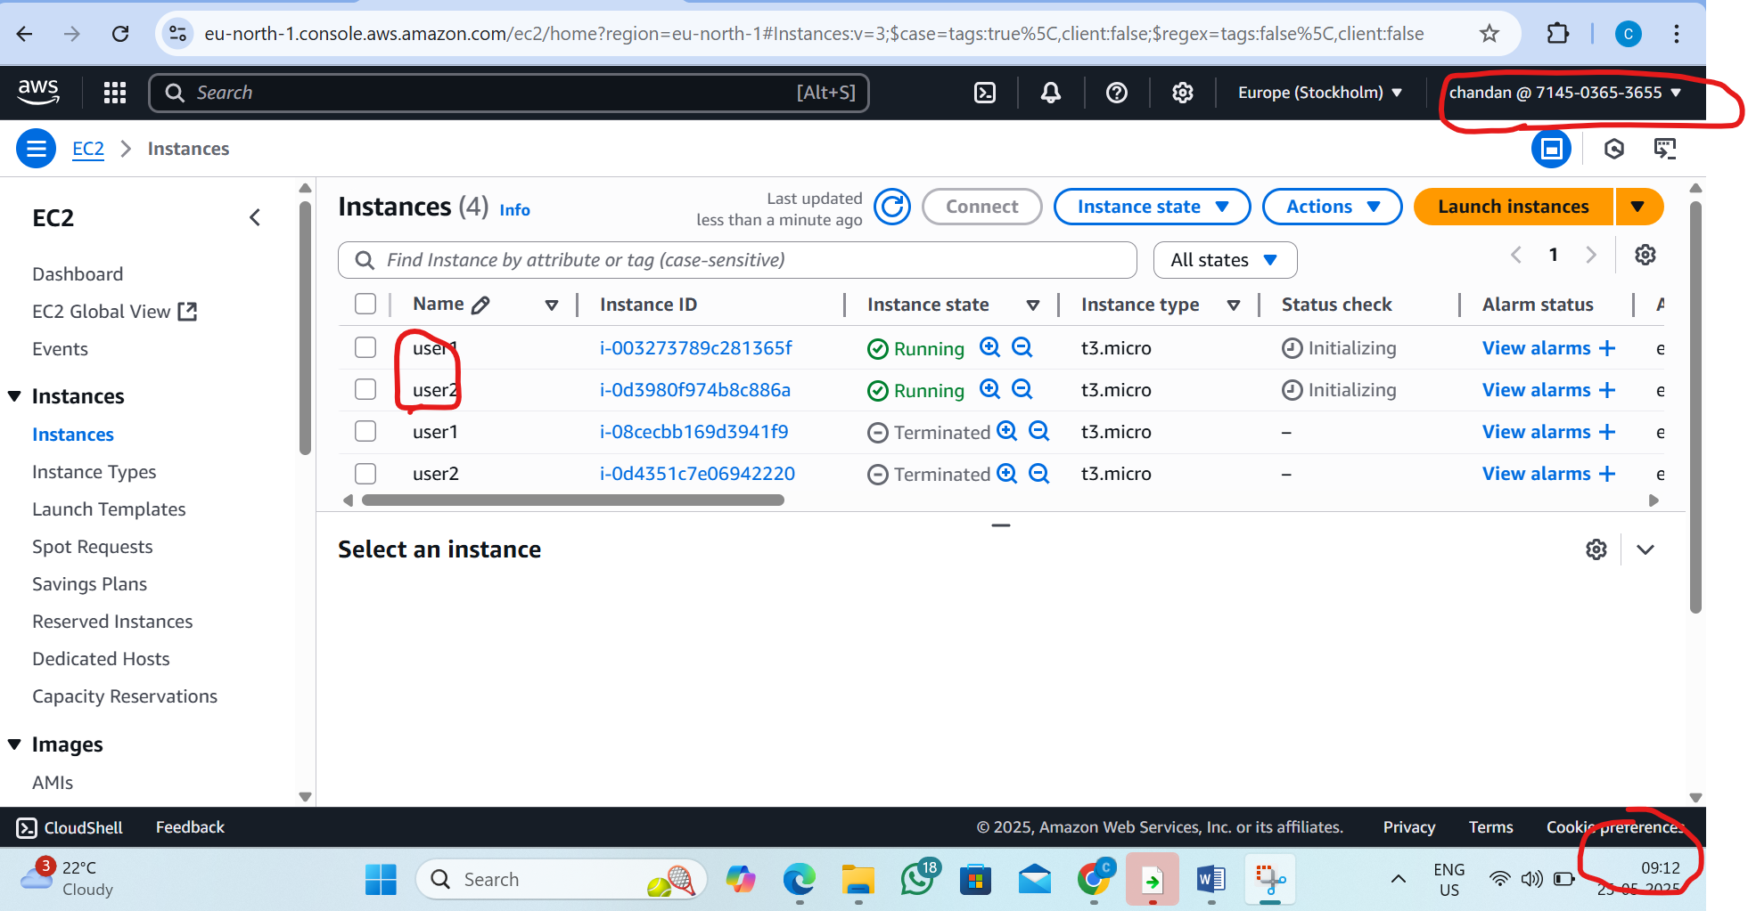
Step 2 :Connect user1 EC2 Ubuntu instance
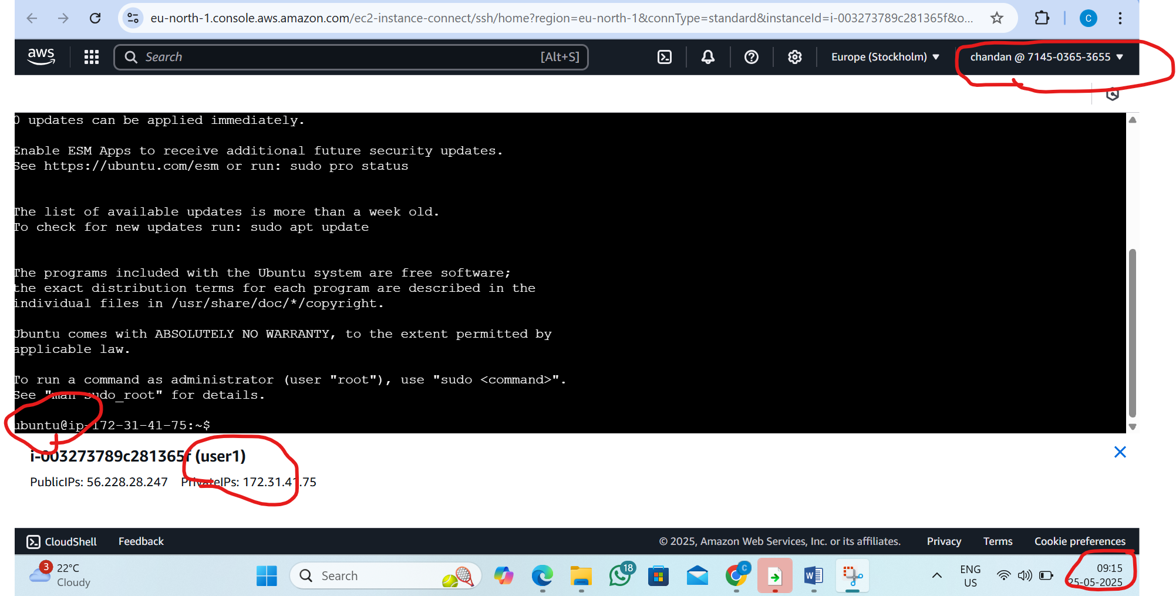

Step 3: we want add the user inside the user1 instance and create password
BY the command :_sudo adduser chandan1
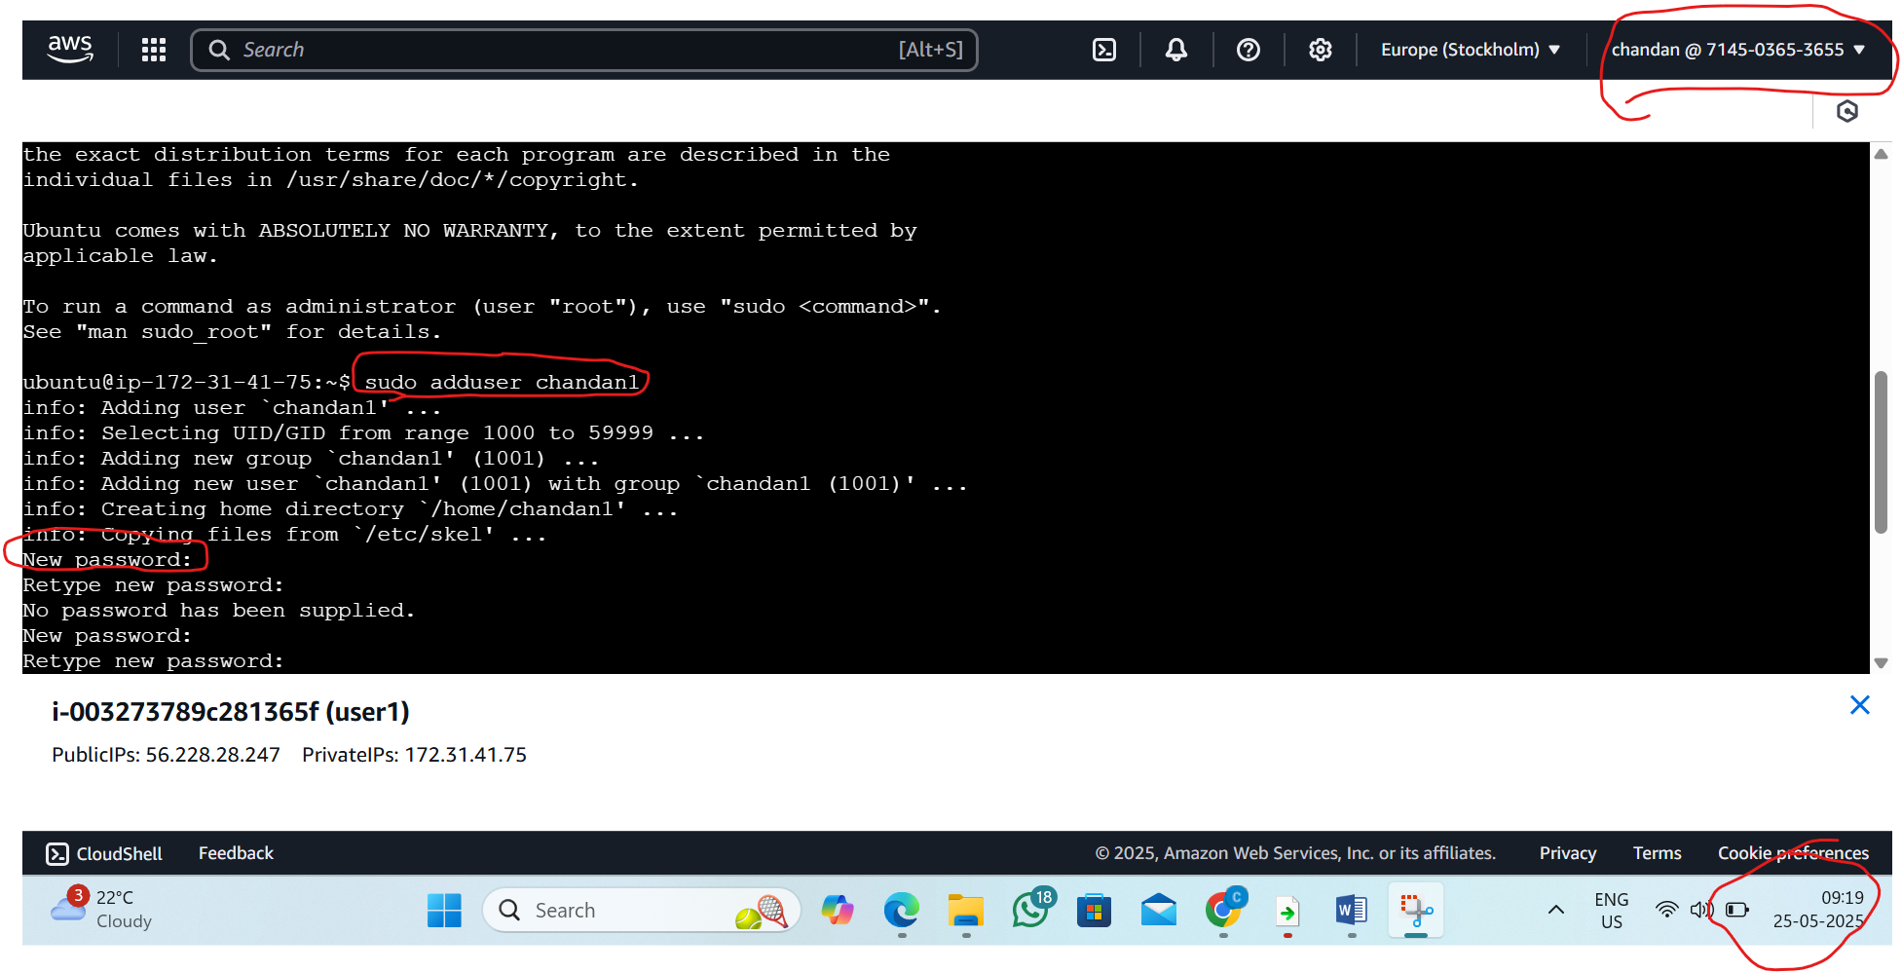
Step 4 :go inside the created user chandan1
By the command: su – chandan1
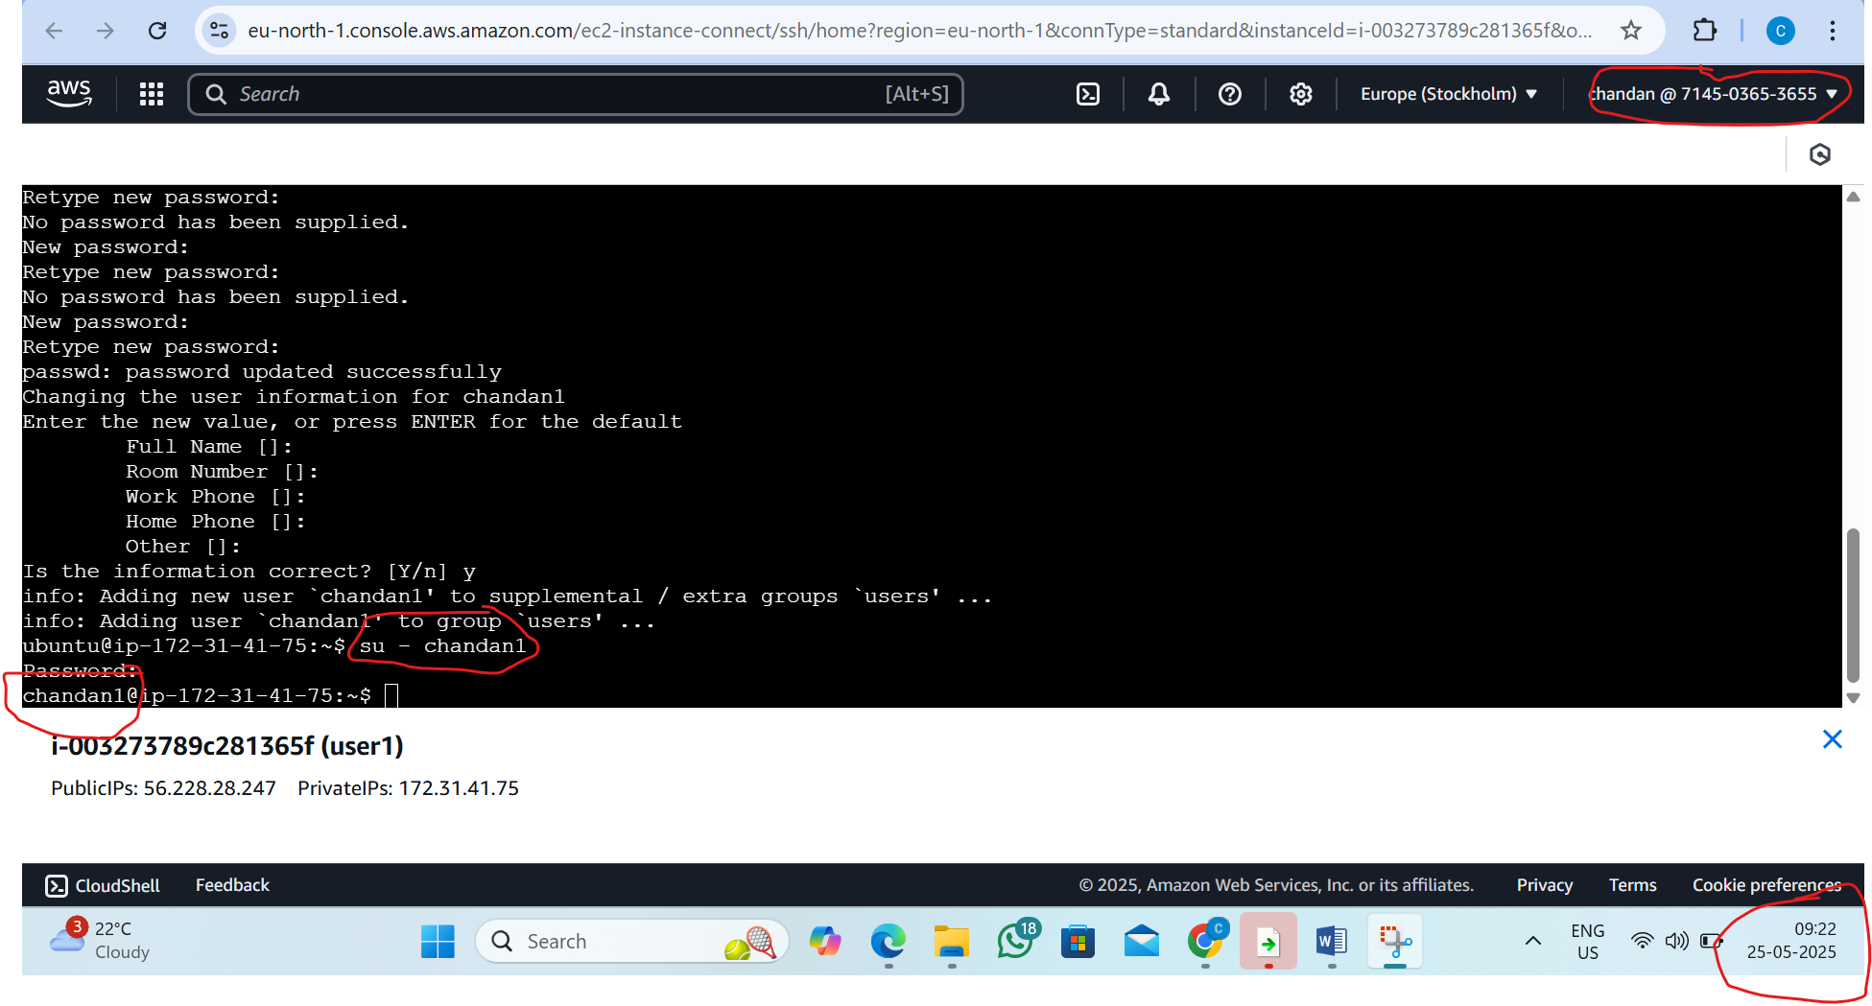

Step 5 : Now generate the ssh key
By the command: ssh-keygen
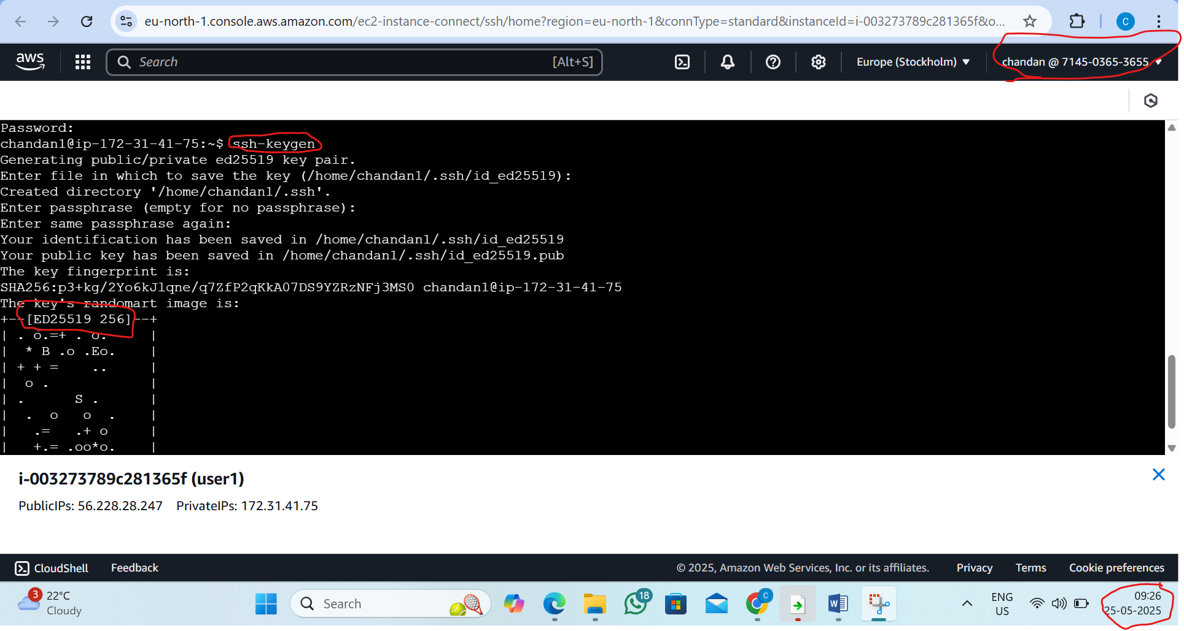

Step 6:go inside the ssh directory and read the key genarated
By the command:
1)ls -a 2)cd .ssh/ 3)ls -a 4) cat id_ed25519.pub
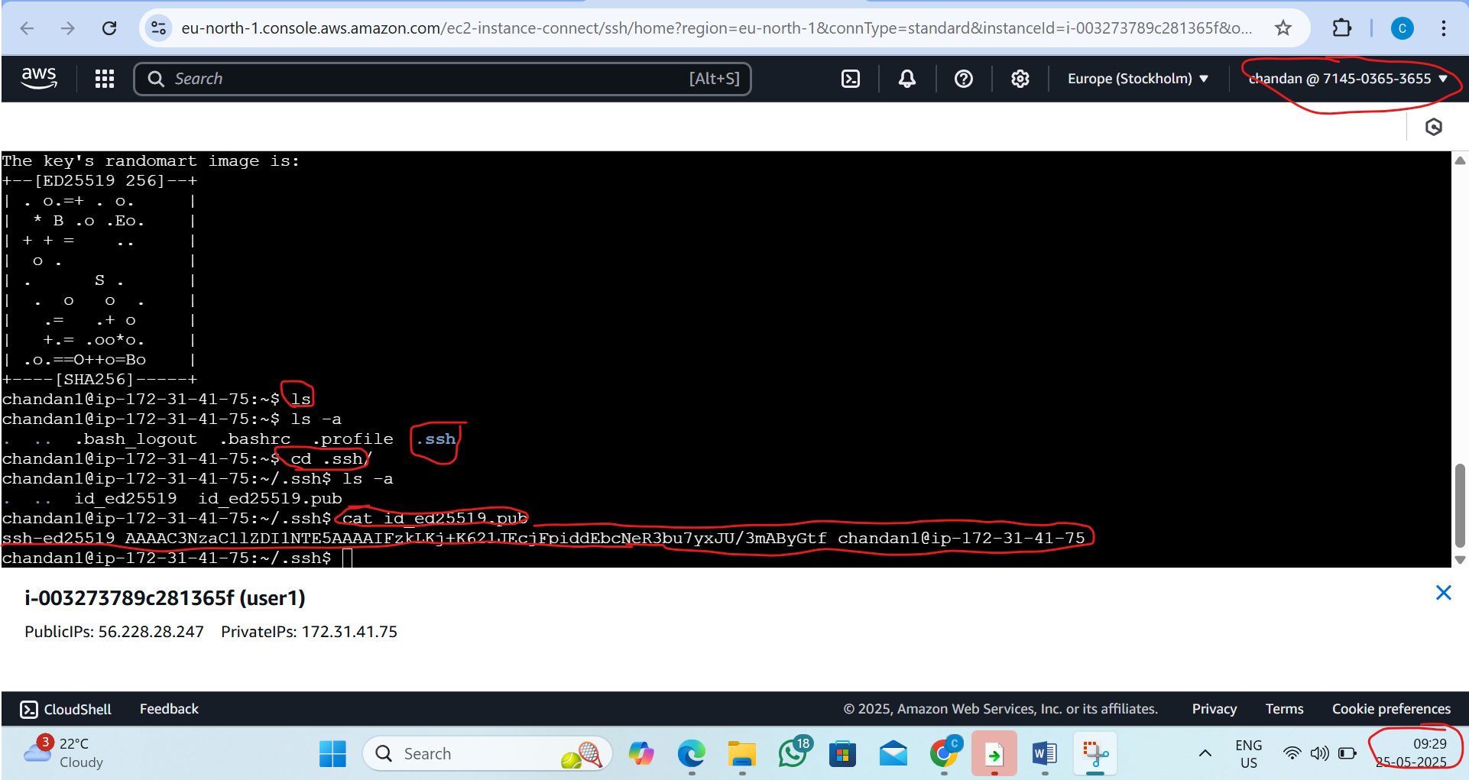
Step7 :now Connect user2 EC2 Ubuntu instance
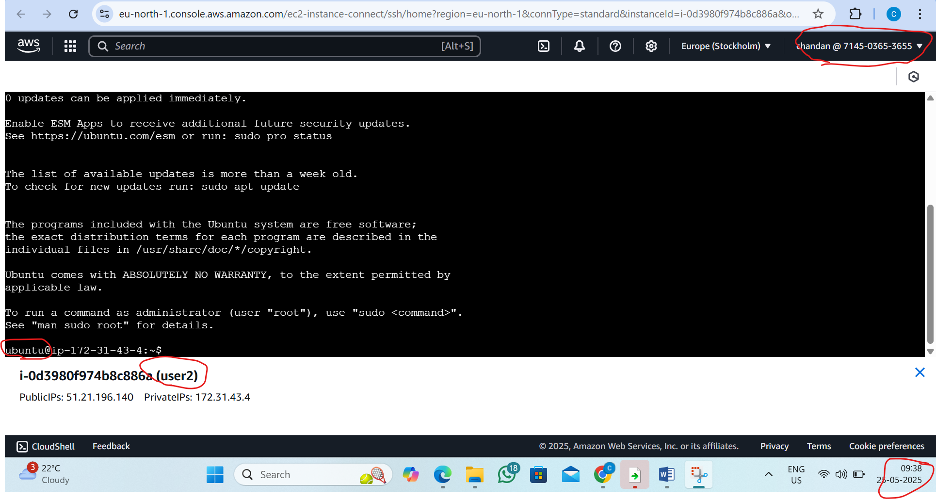

Step8 : we want add the user inside the user2 instance and create password
BY the command :_sudo adduser chandan2
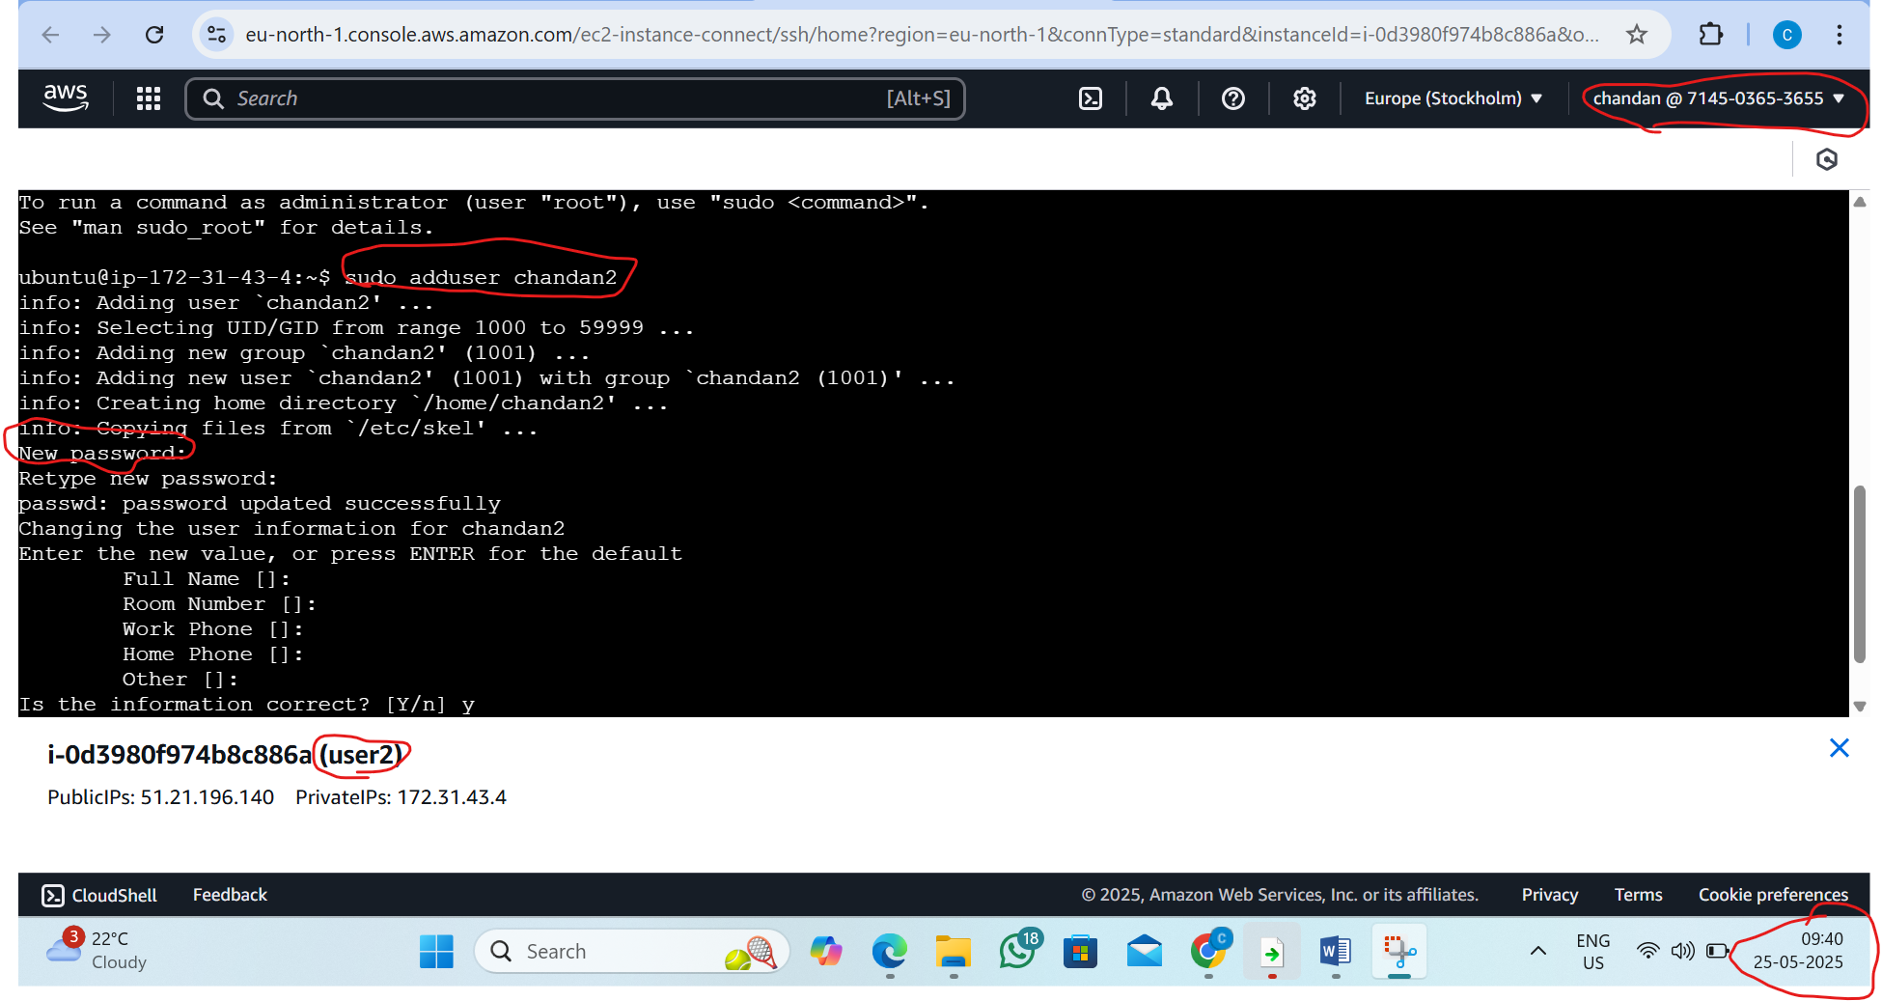

Step 9 : go inside the created user chandan2
By the command: su – chandan2
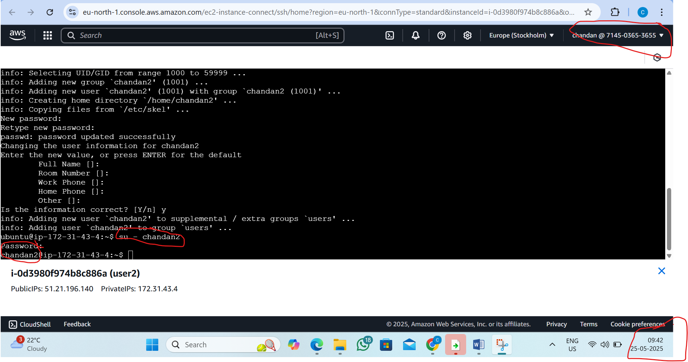

Step 10: make ssh directory and go inside the directory
By the command:1)mkdir .ssh , 2)cd .ssh/
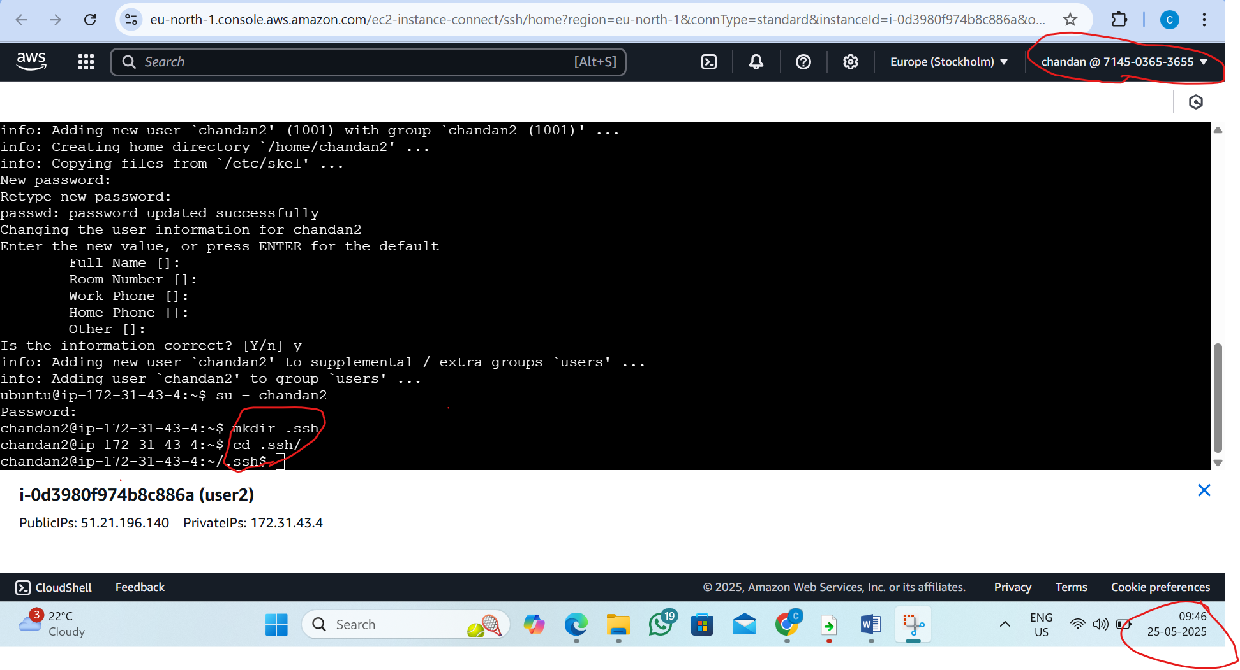

Step 11: now go inside the authorized keys by the vi editor
By the command : vi authorized_keys
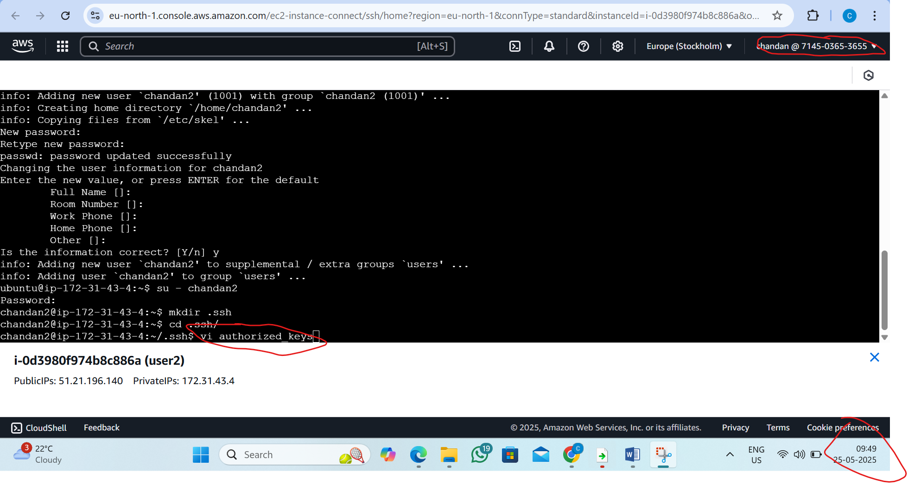
Step 12: now inside the authorized keys follow the following steps
1)press I 2) paste key generated by the user 1
3)press esc 4)type :wq and press enter
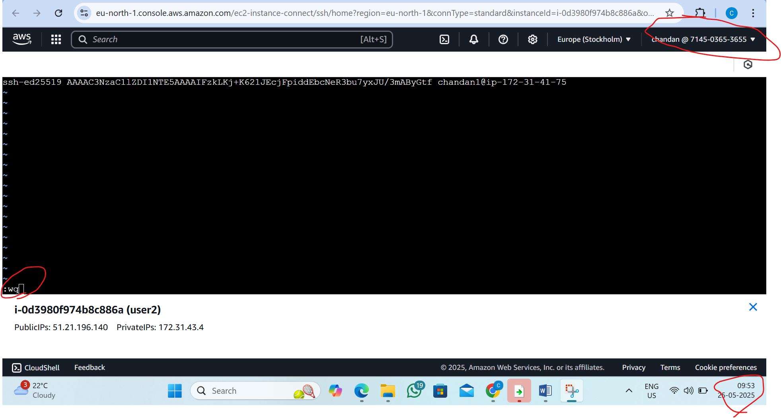
Step13 :copy the public ips in the user 2 and now go to user 1
Follow this steps
1)Pass the command:- ssh chandan2@paste the publicips of user 2(51.21.196.140)
Now overall command:-ssh chandan@51.21.196.140
2) type yes then the user1 can access the user 2
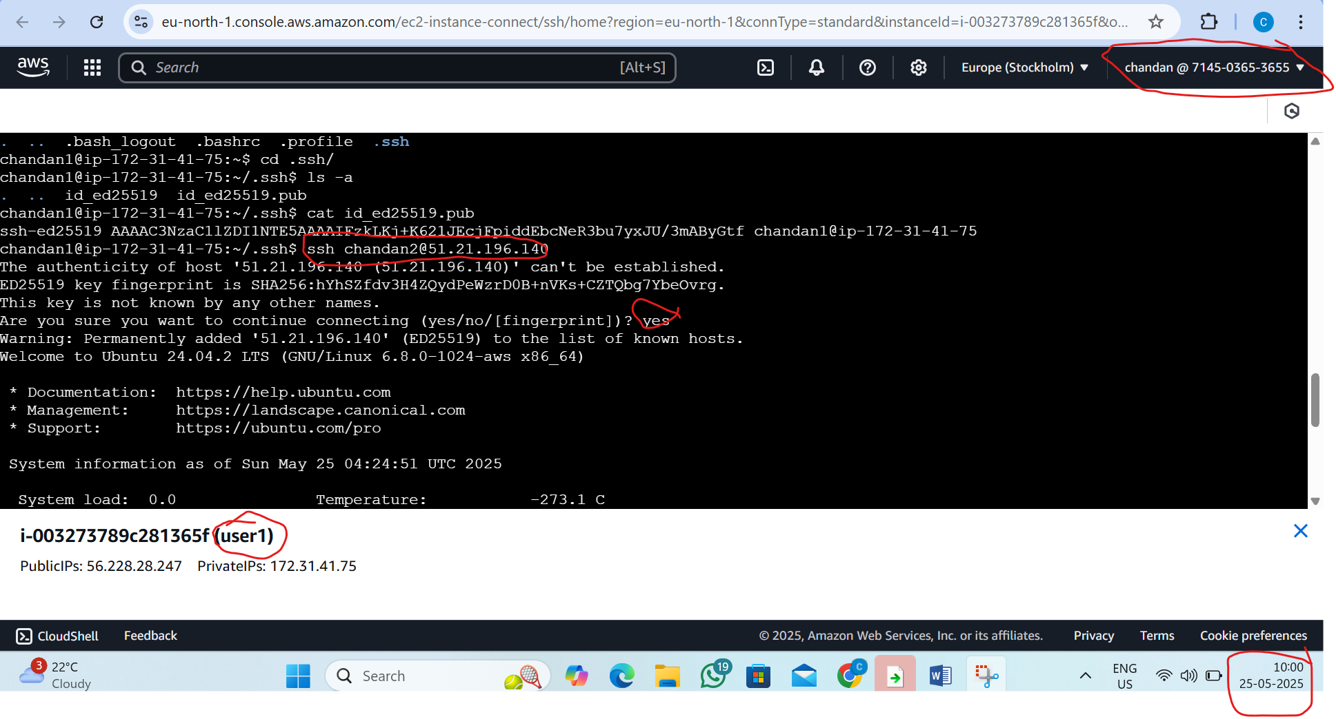
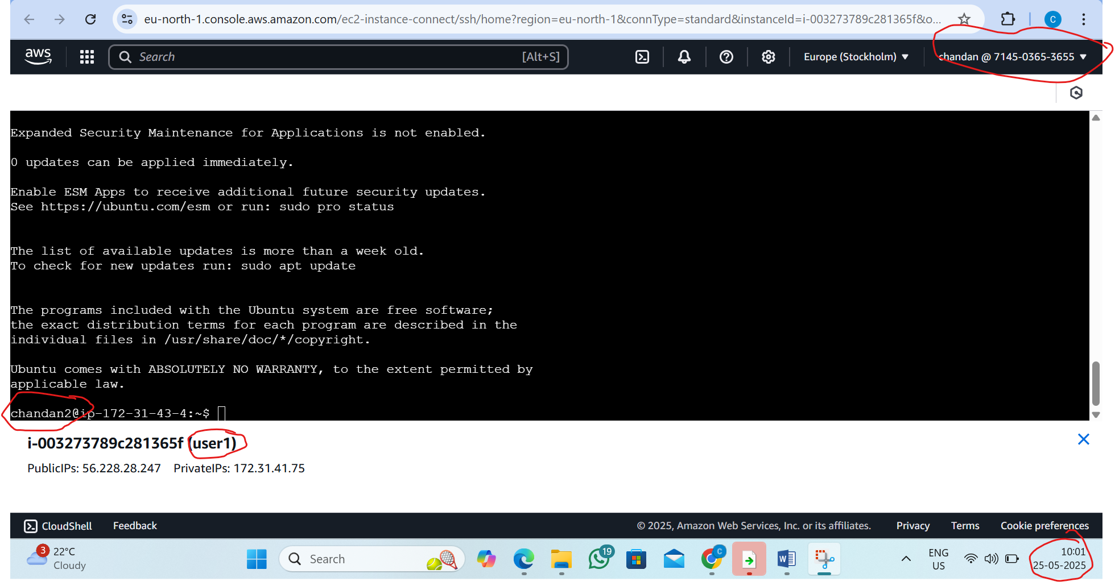
2. L2 - As a Linux root user Create Files/Directory in the same Instance and change the ownership to a new user
Step1 : Lunch EC2 Ubantu instance
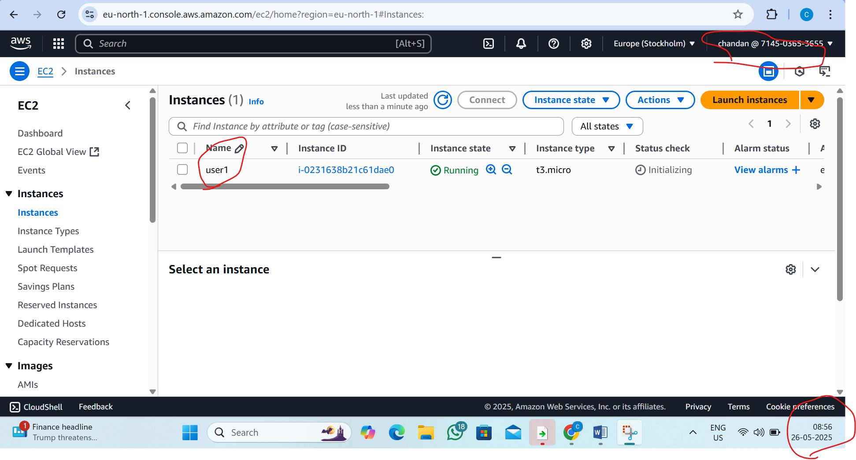

Step2:Connect instance
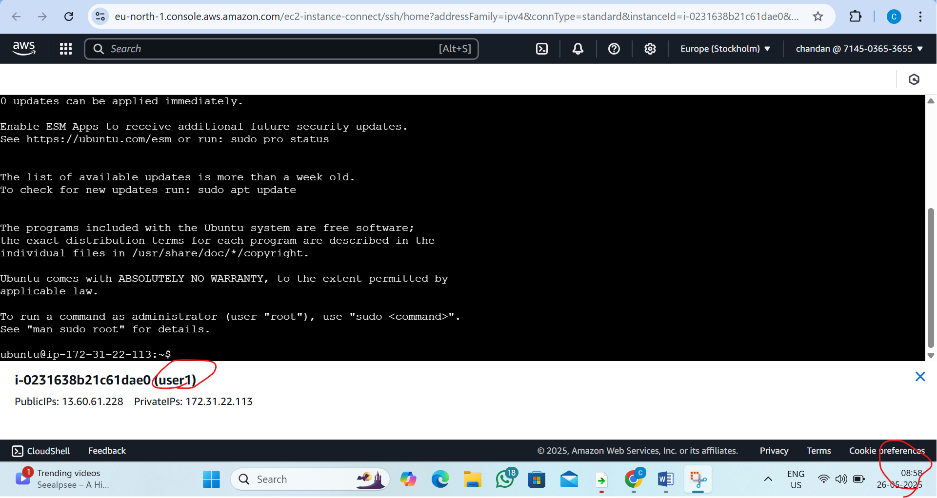

Step3 : Create a New User and set the password
By the command: sudo adduser user1
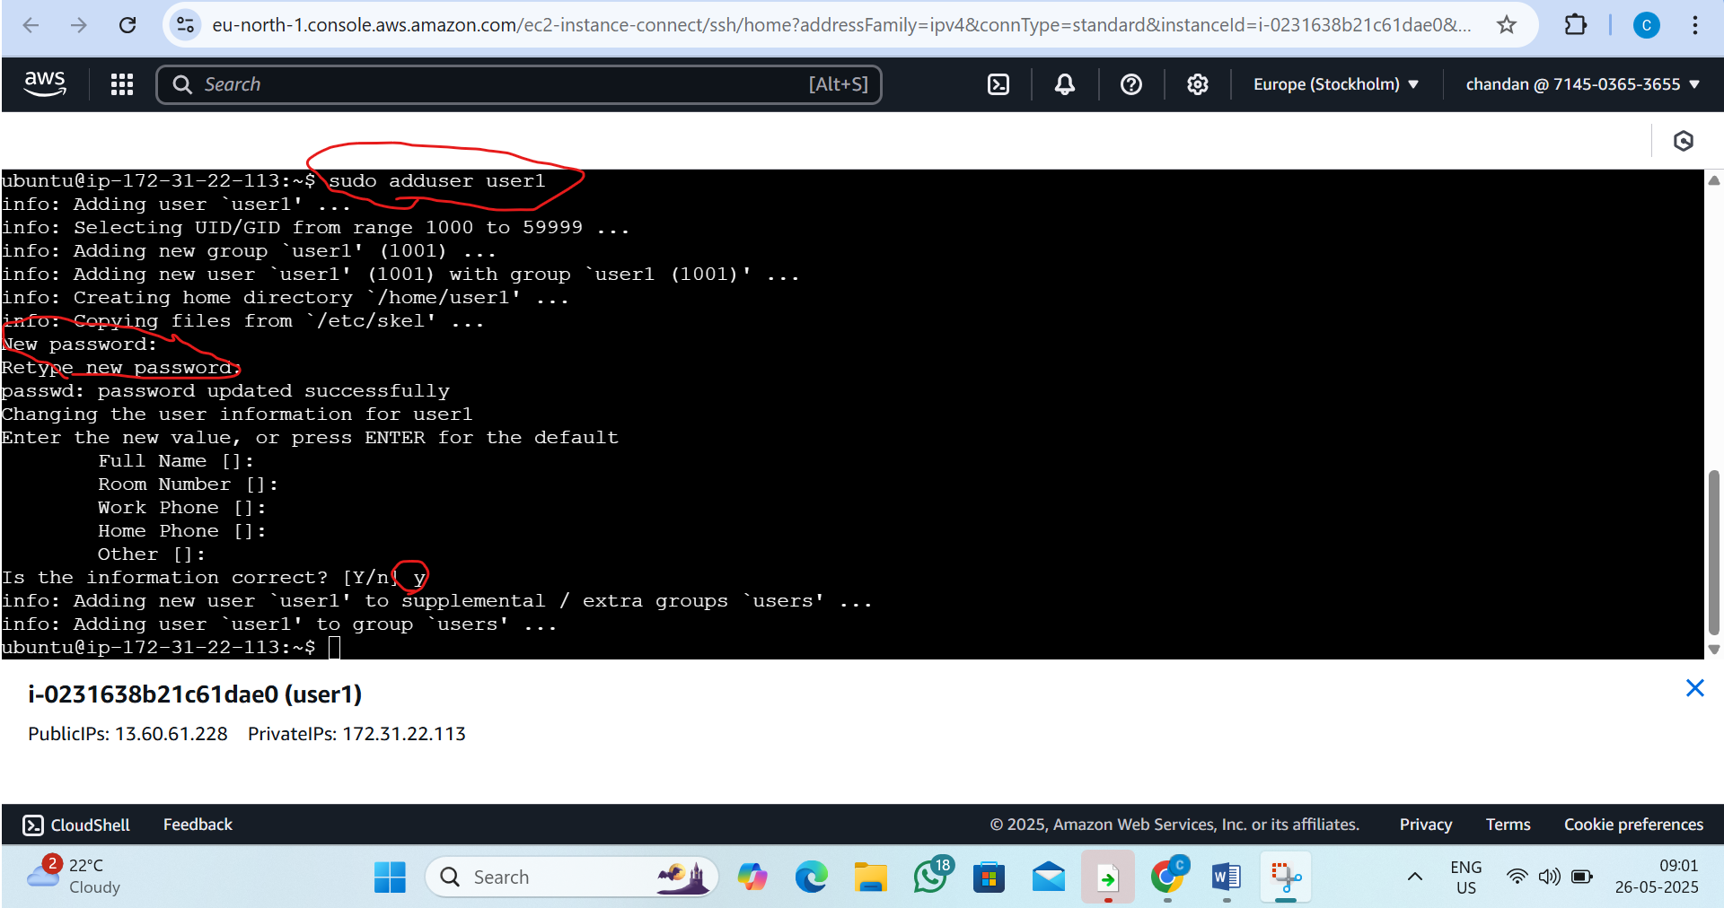
Step4: Create Directory
By the command:sudo mkdir /opt/mkdir
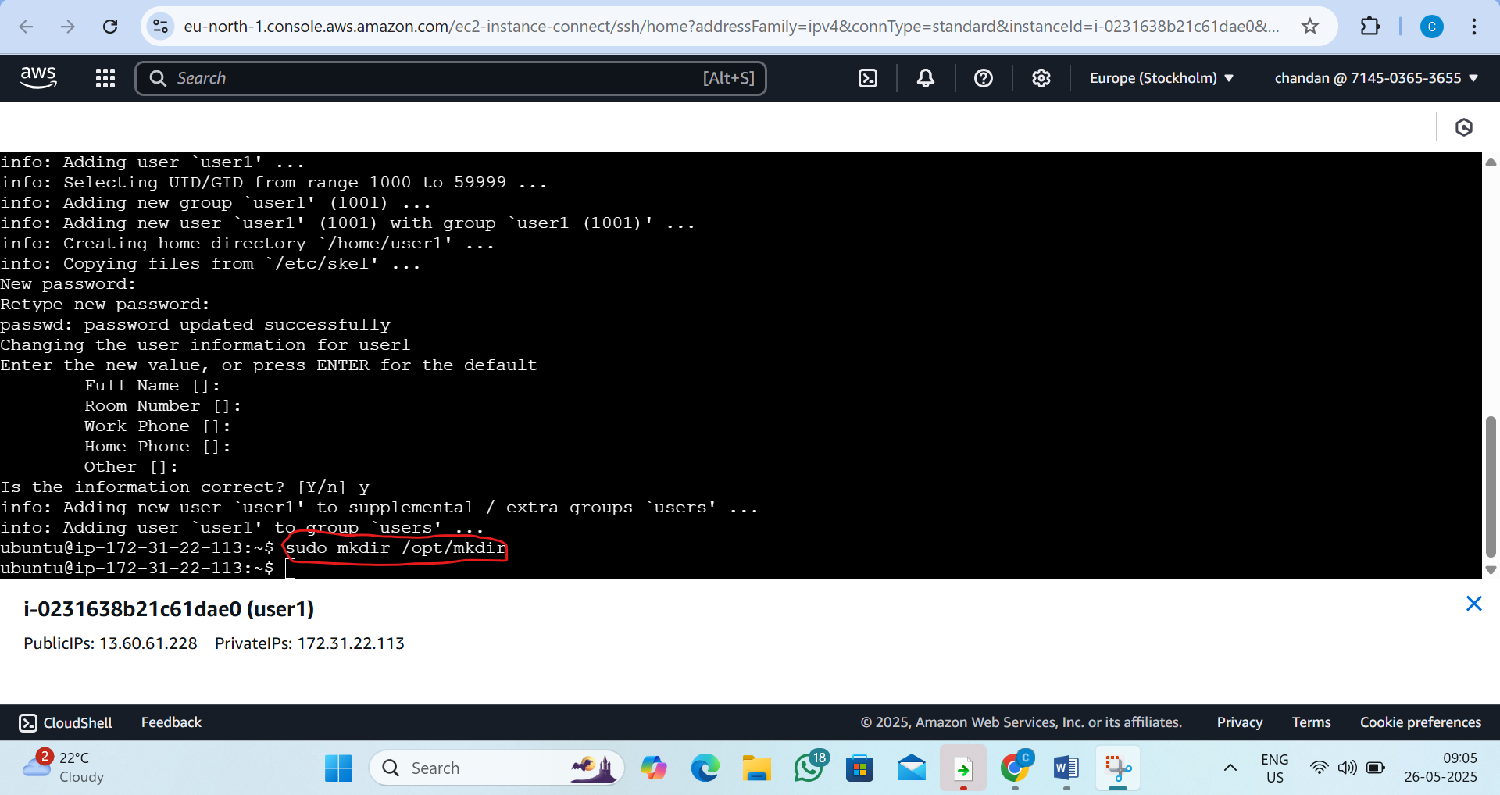

Step5: Create a files file1.txt and file2.txt
By the command:
sudo touch /opt/mkdir/file1.txt /opt/mkdir/file2.txt
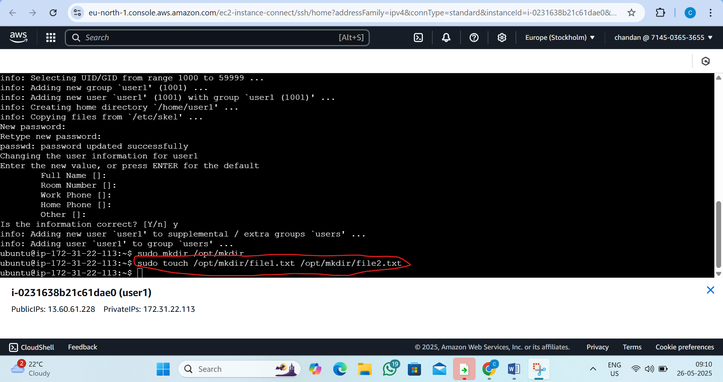
Step6: Change ownership to user1:user1
By the command:
sudo chown -R user1:user1 /opt/mkdir
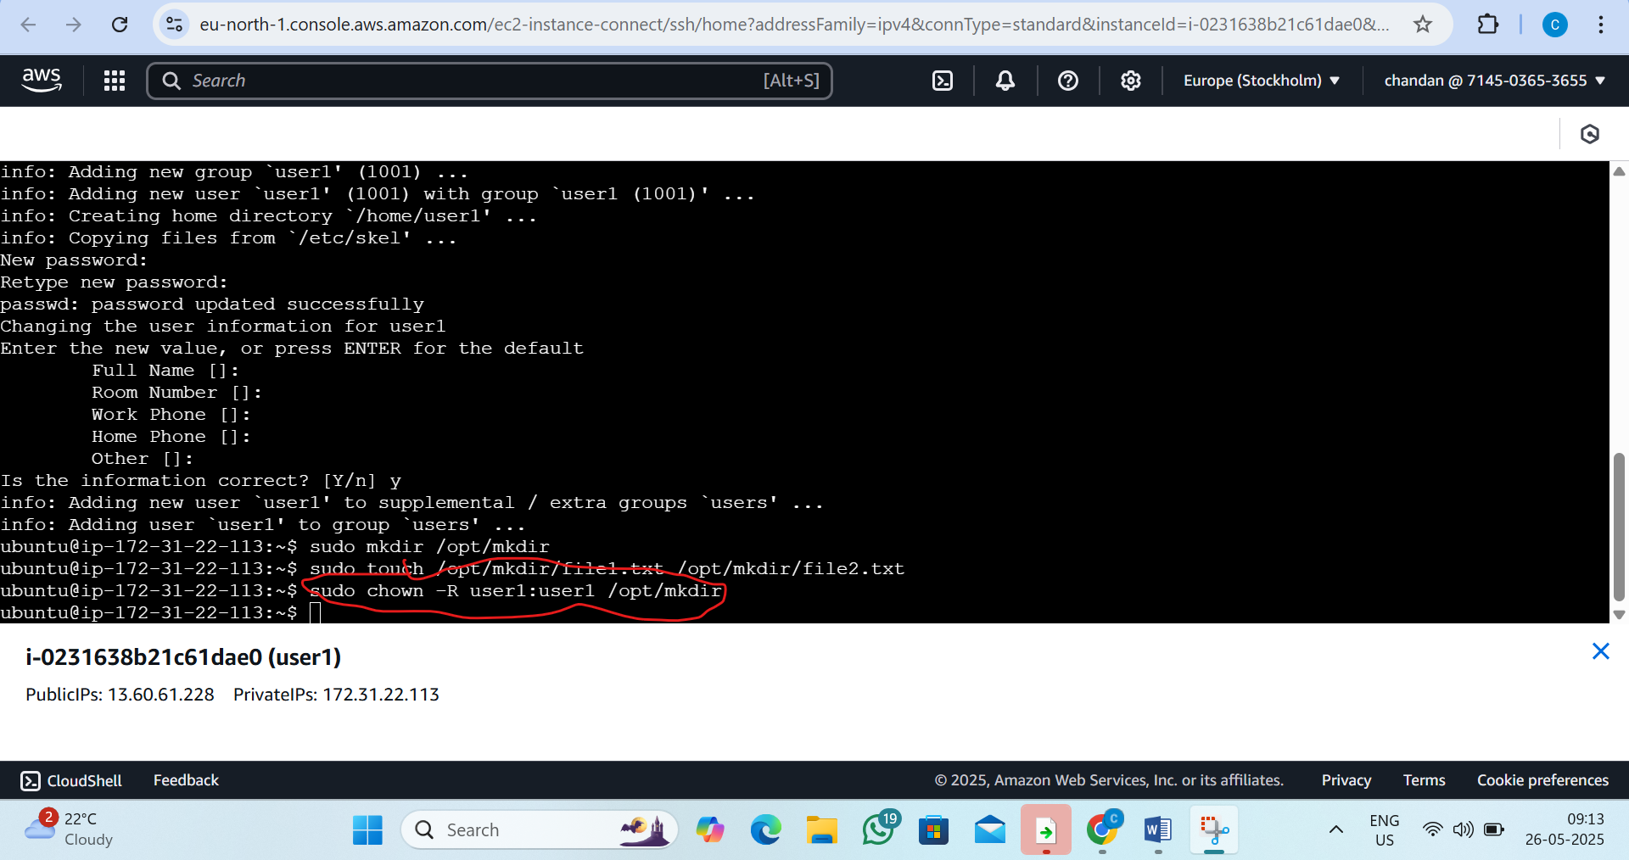
Step7: Verified directory exists
By the command: ls -l /opt/mkdir
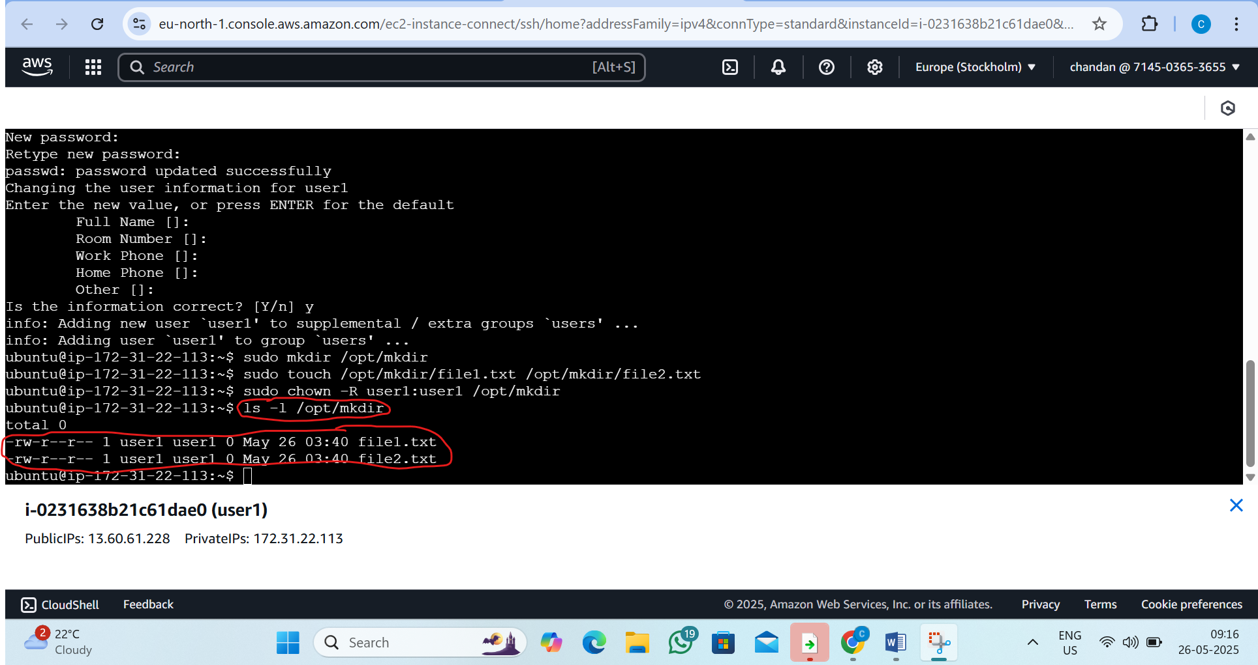

3. L3 - In EC2 Ubuntu Instance Create Files and Directories and Grand R/W/X Access only to the Owner and User Group
Step1 : Lunch EC2 Ubantu instance


Step2:Connect instance

Step3: Create a Directory
By command:1) mkdir /home/ubuntu/project1
2)cd /home/ubuntu/project1
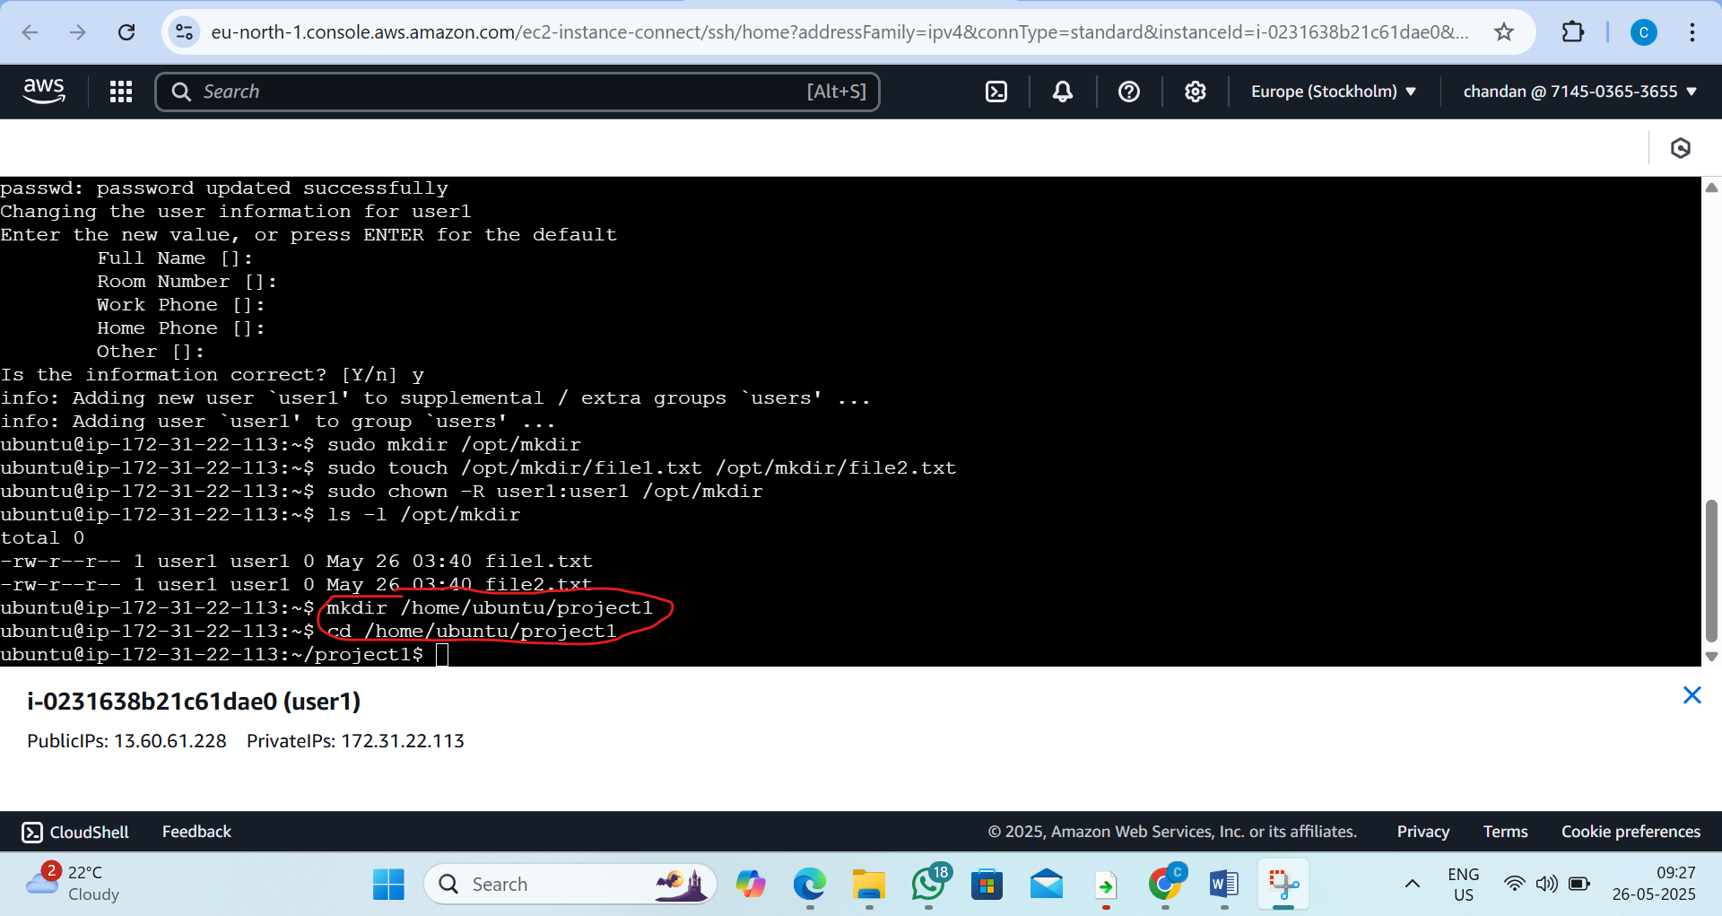
Step4:Create sample files
By Command : touch file1.txt file2.txt
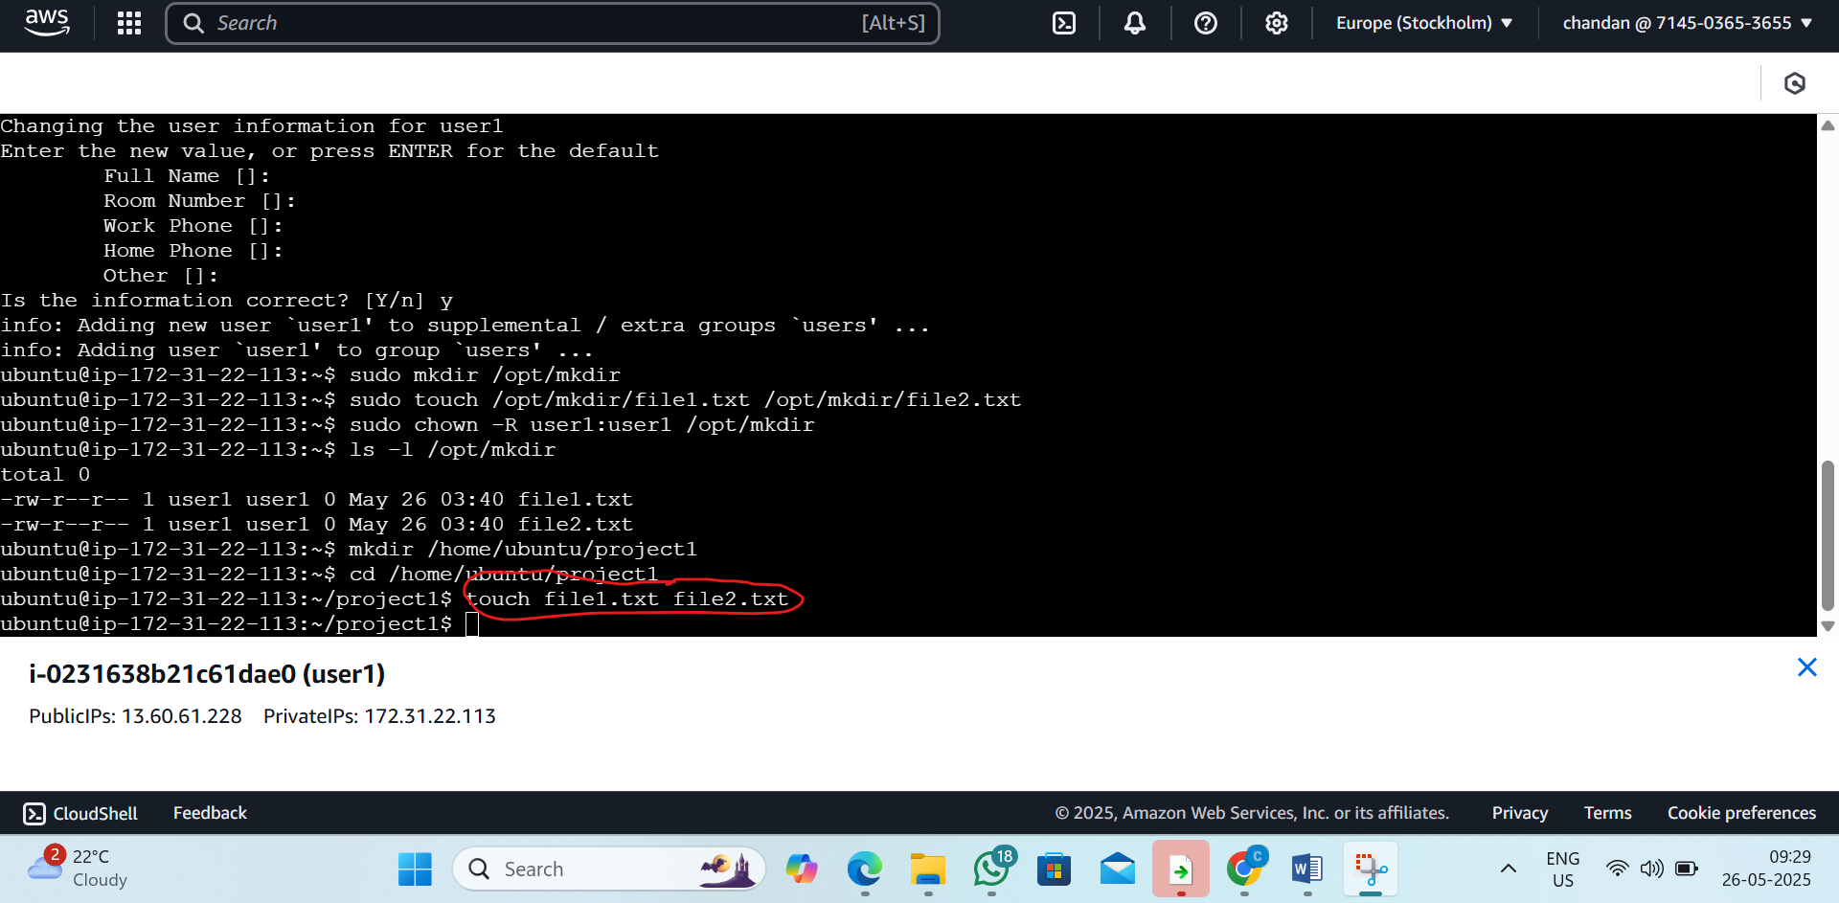

Step5:create the usergroup
By the command:sudo groupadd projectgroup
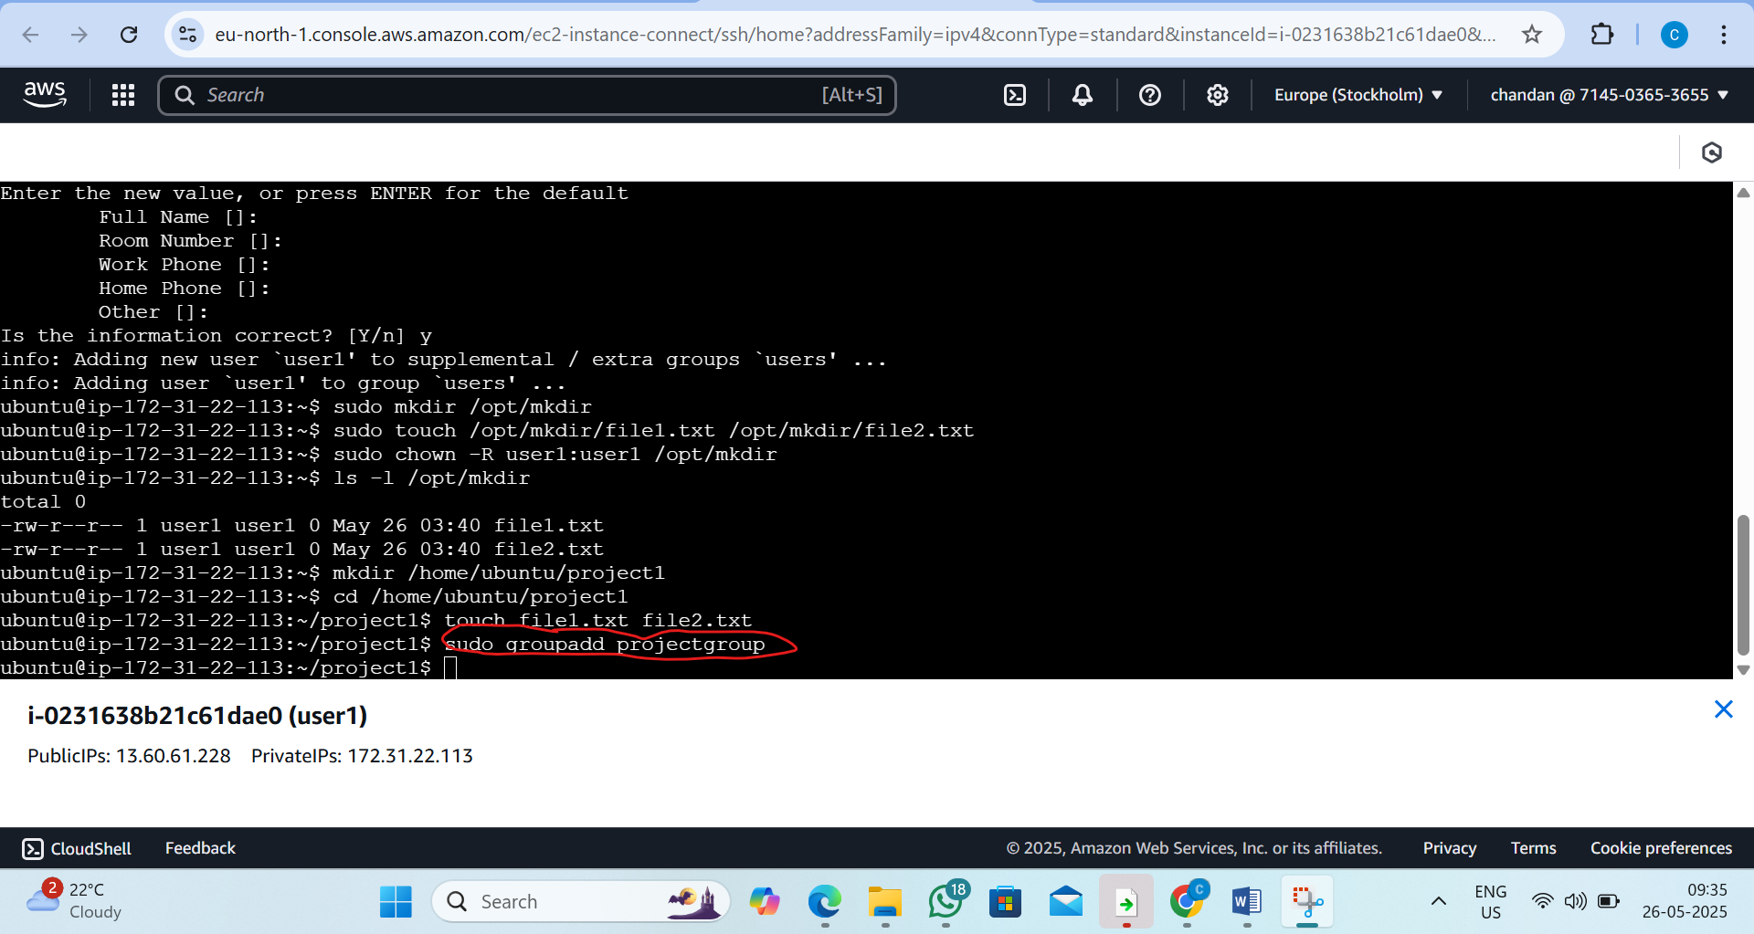
Step6: Add your current user (ubuntu) to the group
By command: sudo usermod -aG projectgroup ubuntu
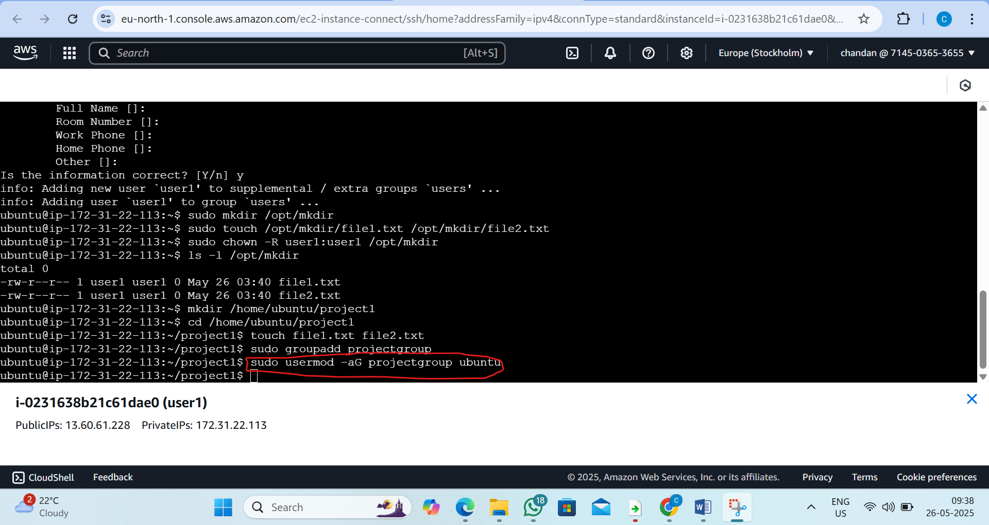

Step7: log out and log back in for group changes to take effect.
By command: 1)exit 2)Reconnet the ec2 ubunto
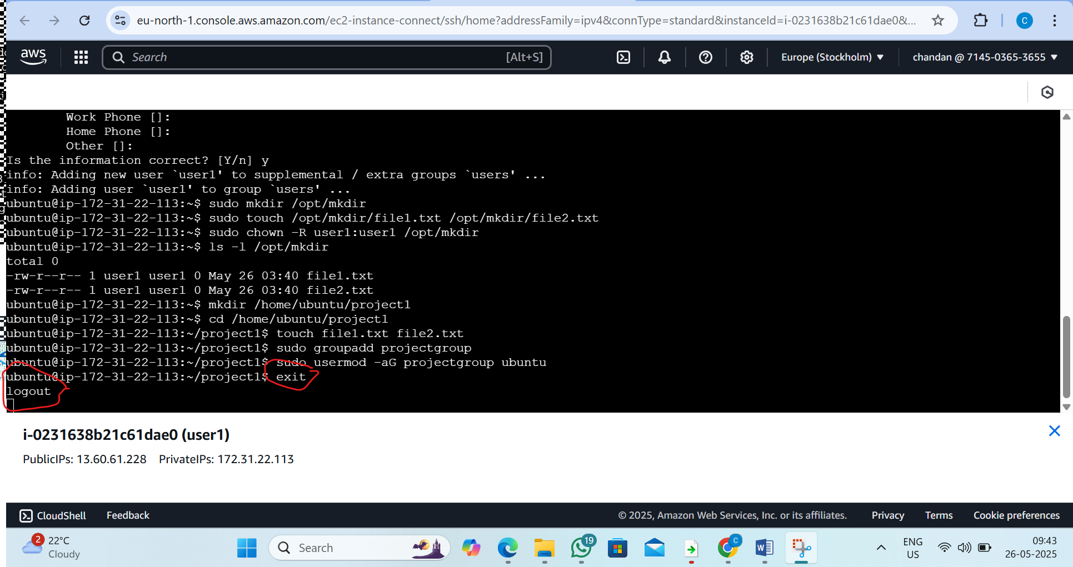
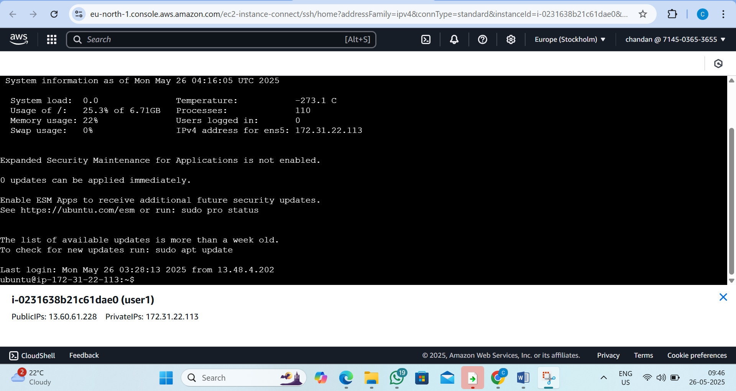

Step 8: Change Group Ownership of the Directory
By the command:
sudo chgrp -R projectgroup /home/ubuntu/project1
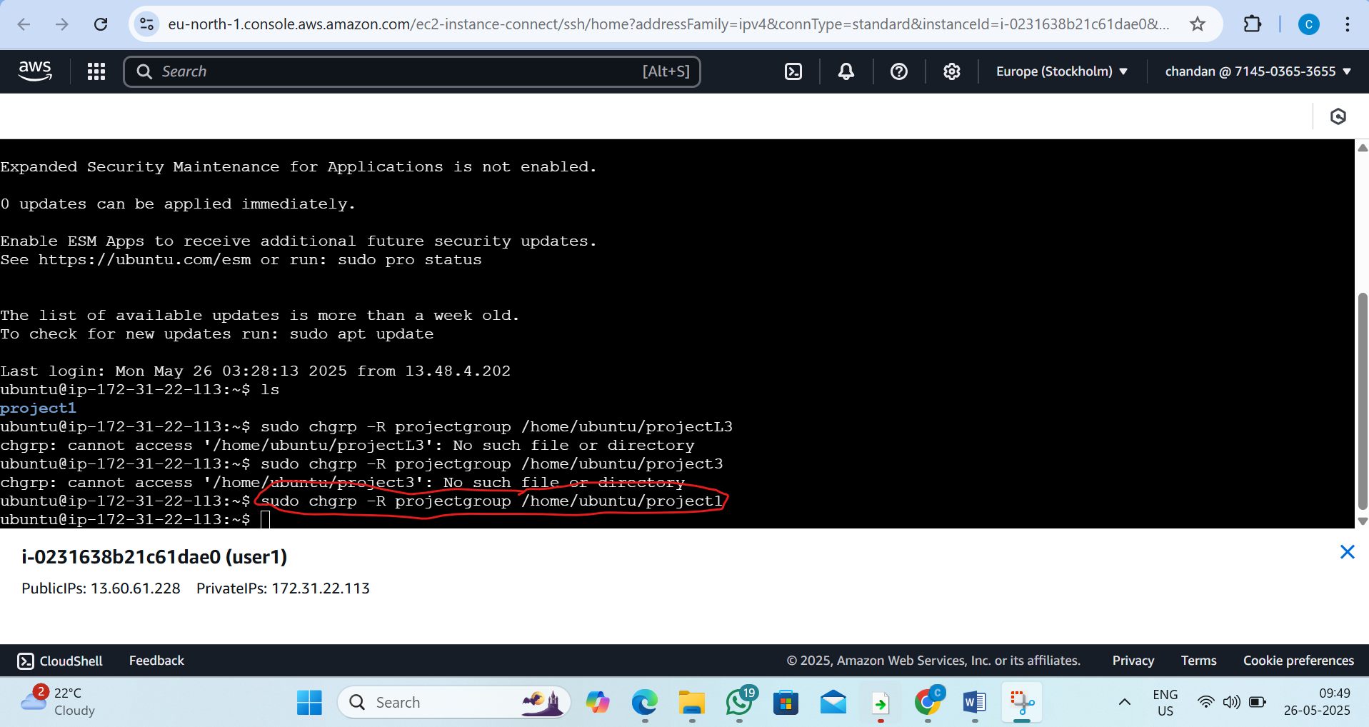
Step 9: Set Proper Permissions
By the command: chmod -R 770 /home/ubuntu/project1
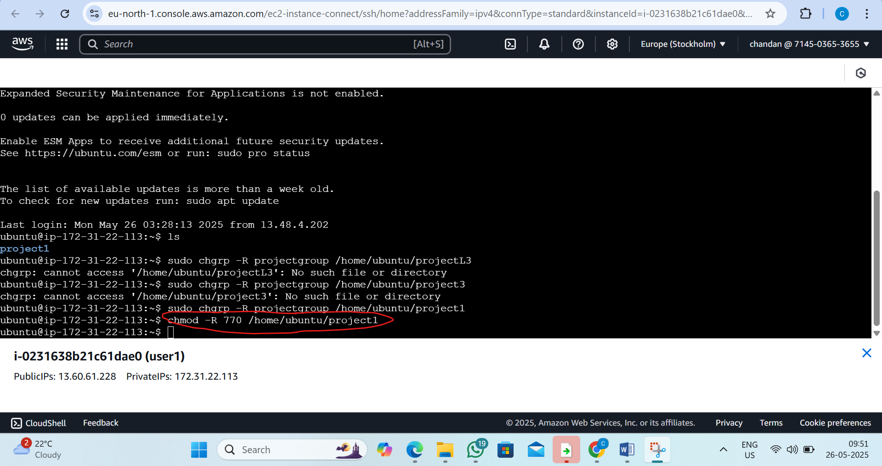

Step10: Verify Permissions
By command: ls -l /home/ubuntu/project1
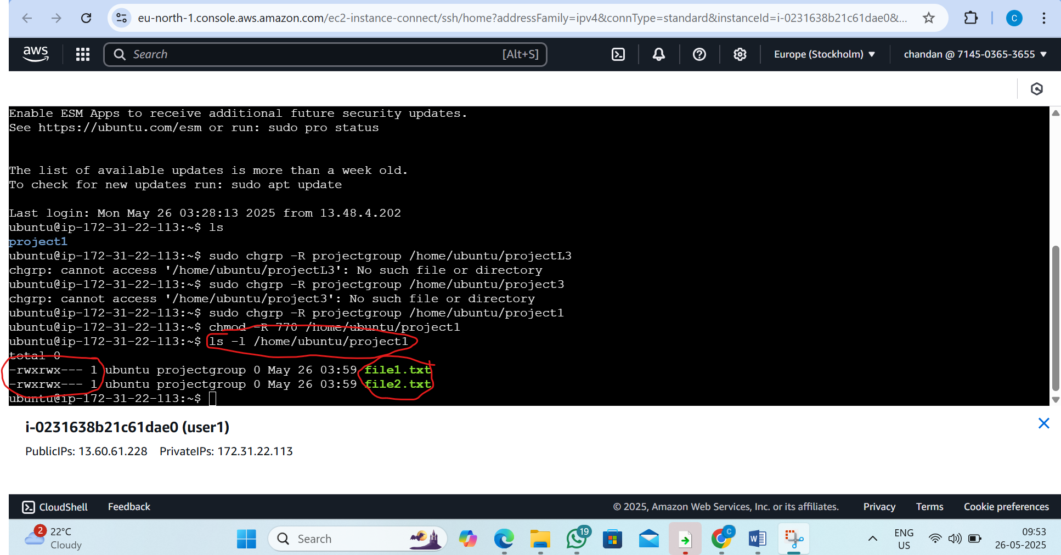

4. L4 - In EC2 Ubuntu Instance install JDK and setup JAVA_HOME path environment variable

Step 1: Update System Packages By the command: sudo apt update

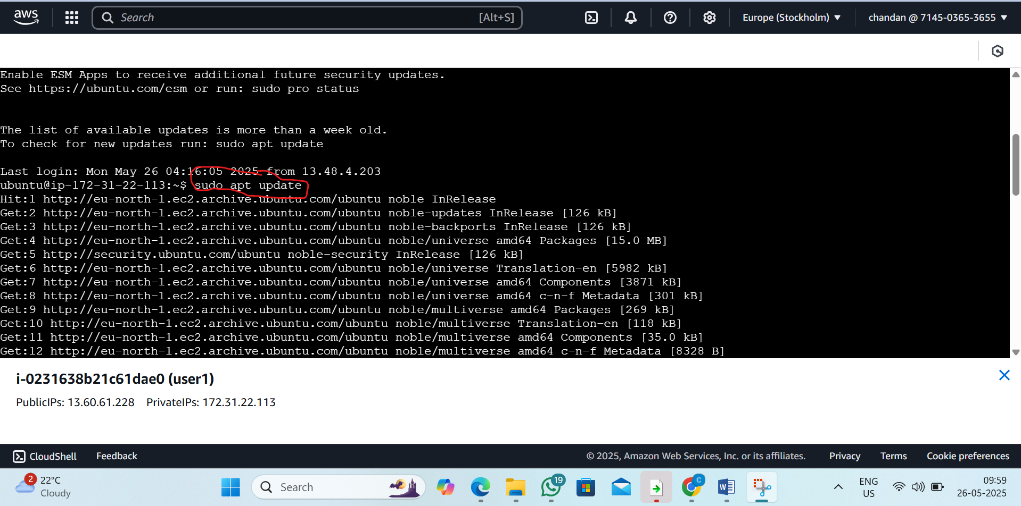

Step2: Install JDK 17 and check the version
By the command:1) sudo apt install -y openjdk-17-jdk 2) java -version

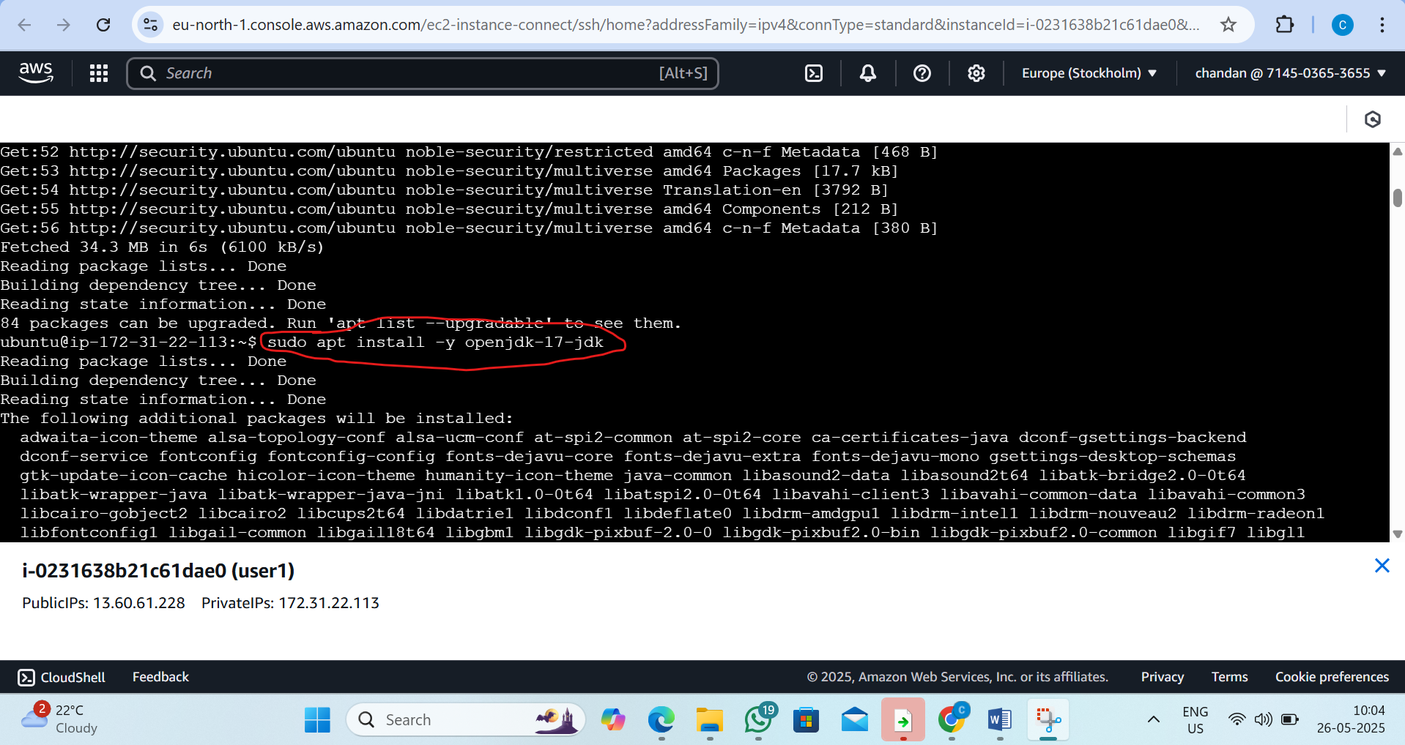

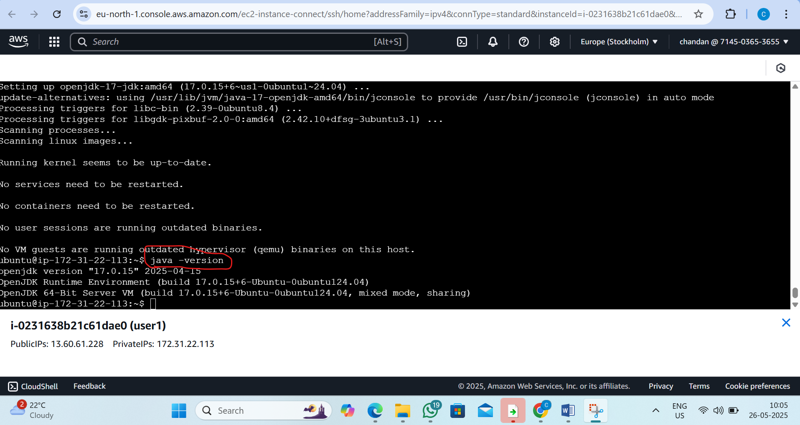

Step 3:To know the path of java file location

By the command :1) cd /usr/lib/jvm/ 2)ls 3) cd java-17-openjdk-amd64 4)ls

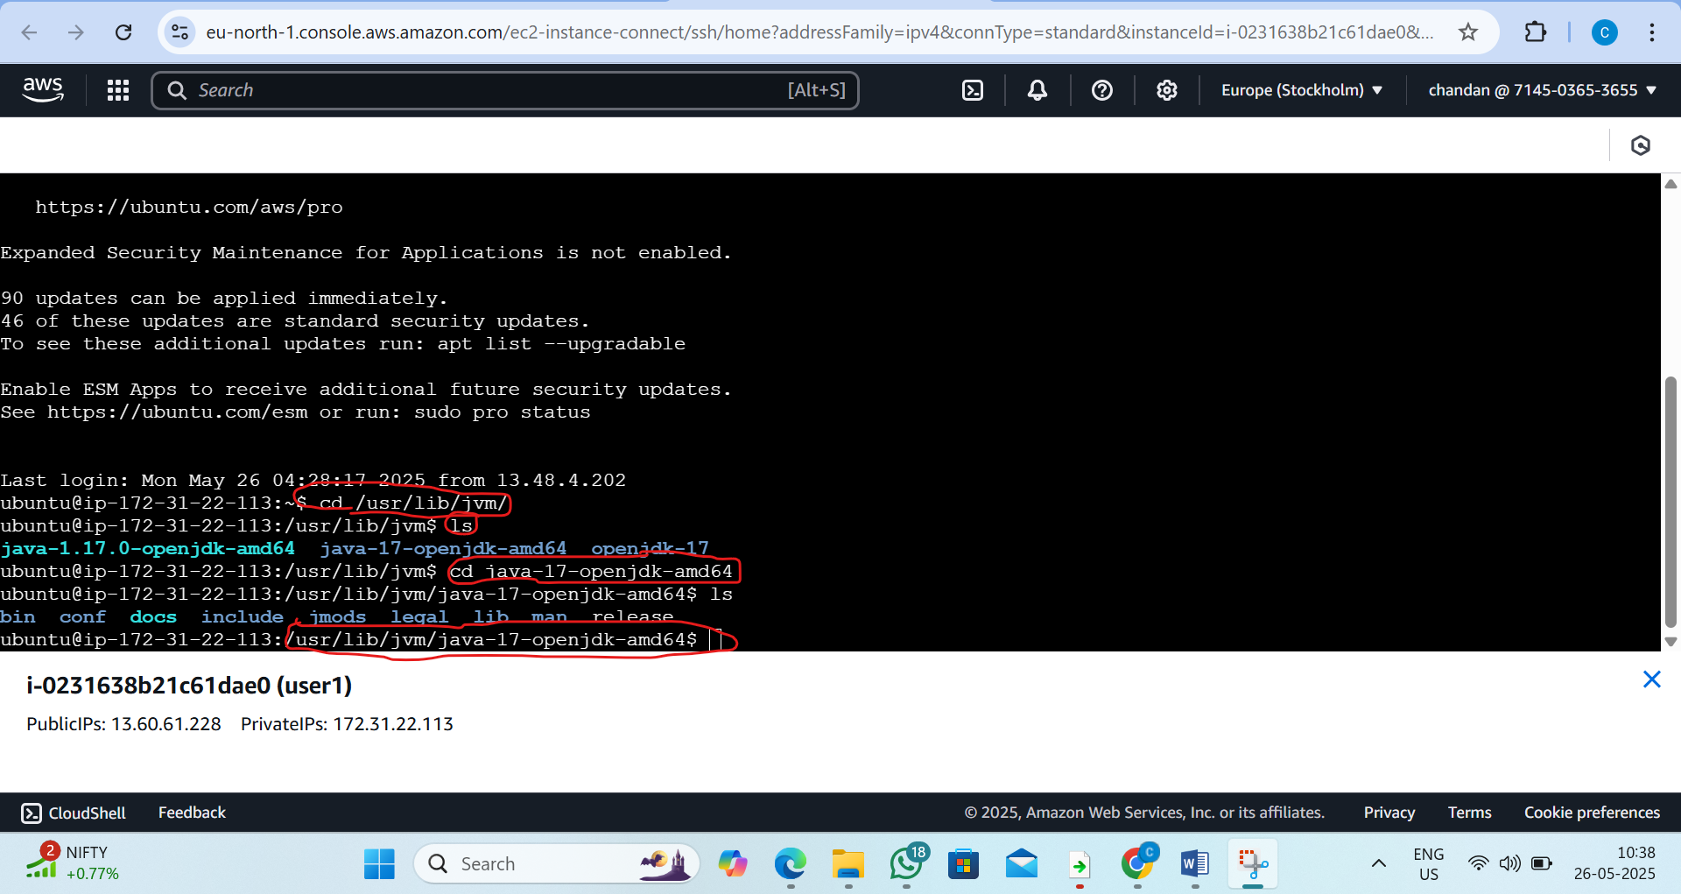

Step4:Now paste the path in following steps

Floow the steps: 1)sudo vi/etc/environment 2)press i 3)inside paste path 4)and press esc :wq and enter

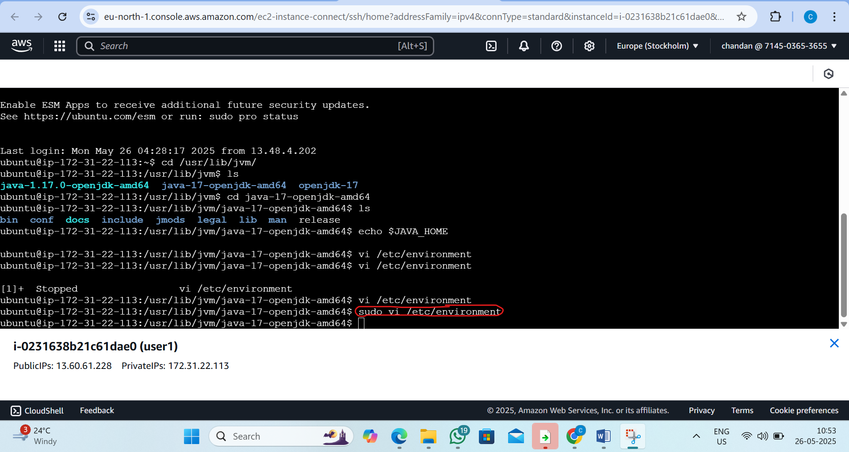

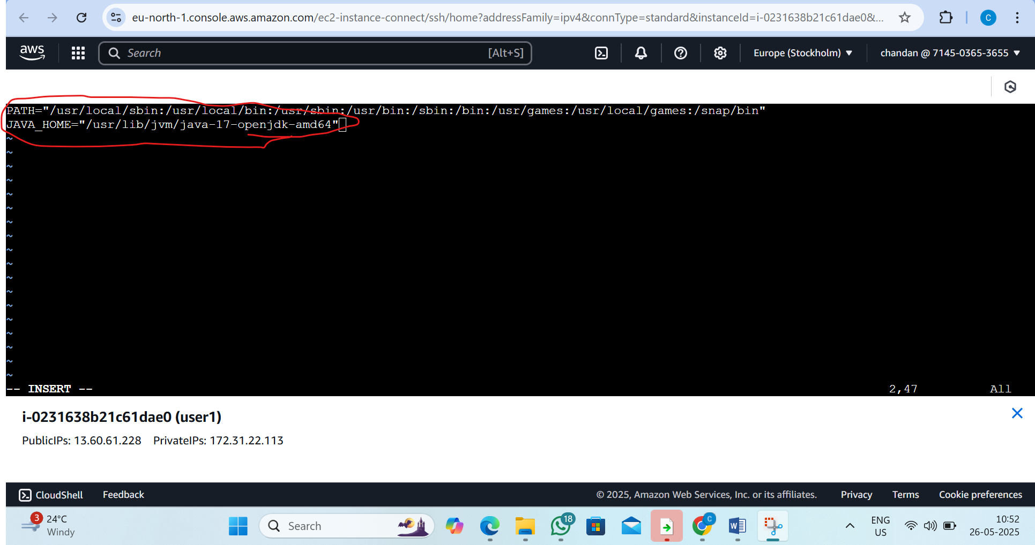

Step5:1)change the directory to user Ubuntu
by command:cd /home/ubuntu/
2)to refersh pass the command : source /etc/environment
3)now pass the command:echo $JAVA_HOME
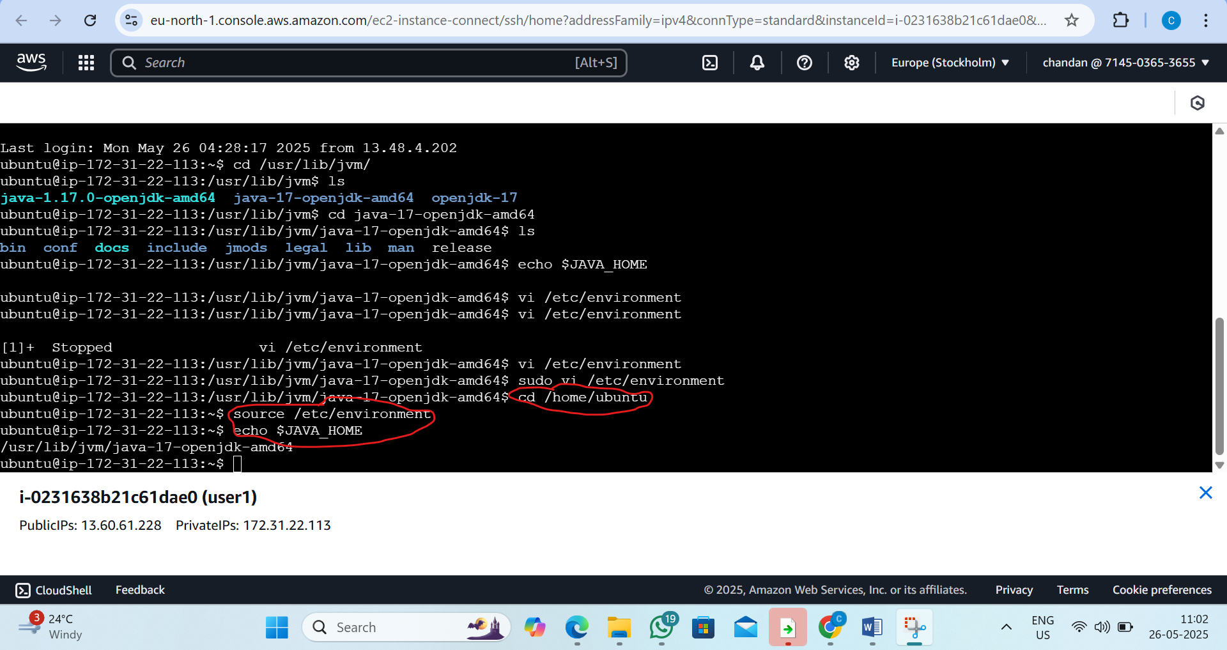

5. L5 - Create two AWS EC2 Ubuntu Instances to establish SSH Connection and SCP the files from one Instance to another instance
STEP1 :-Create Two EC2 Ubuntu Instance User1 and User2
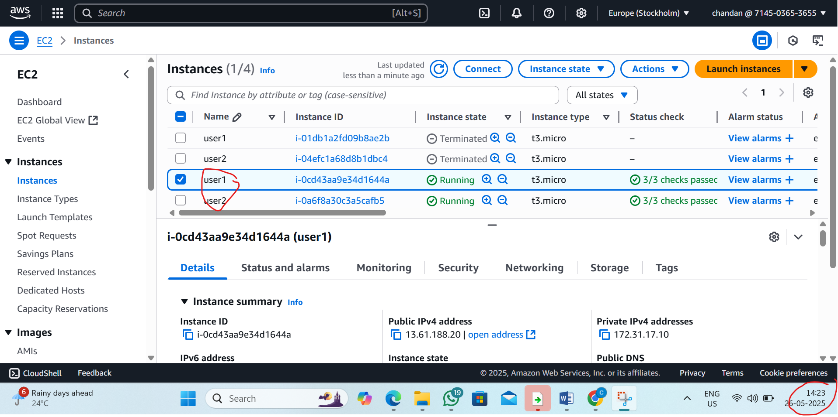
Step 2 :Connect user1 EC2 Ubuntu instance
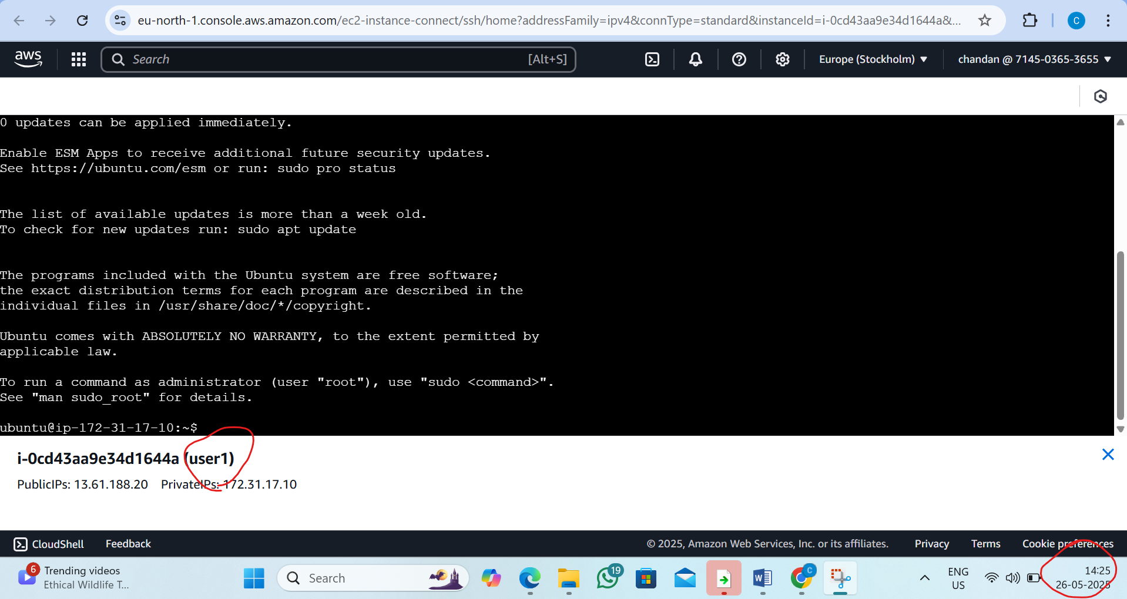

Step 3: we want add the user inside the user1 instance and create password
BY the command :_sudo adduser chandan1
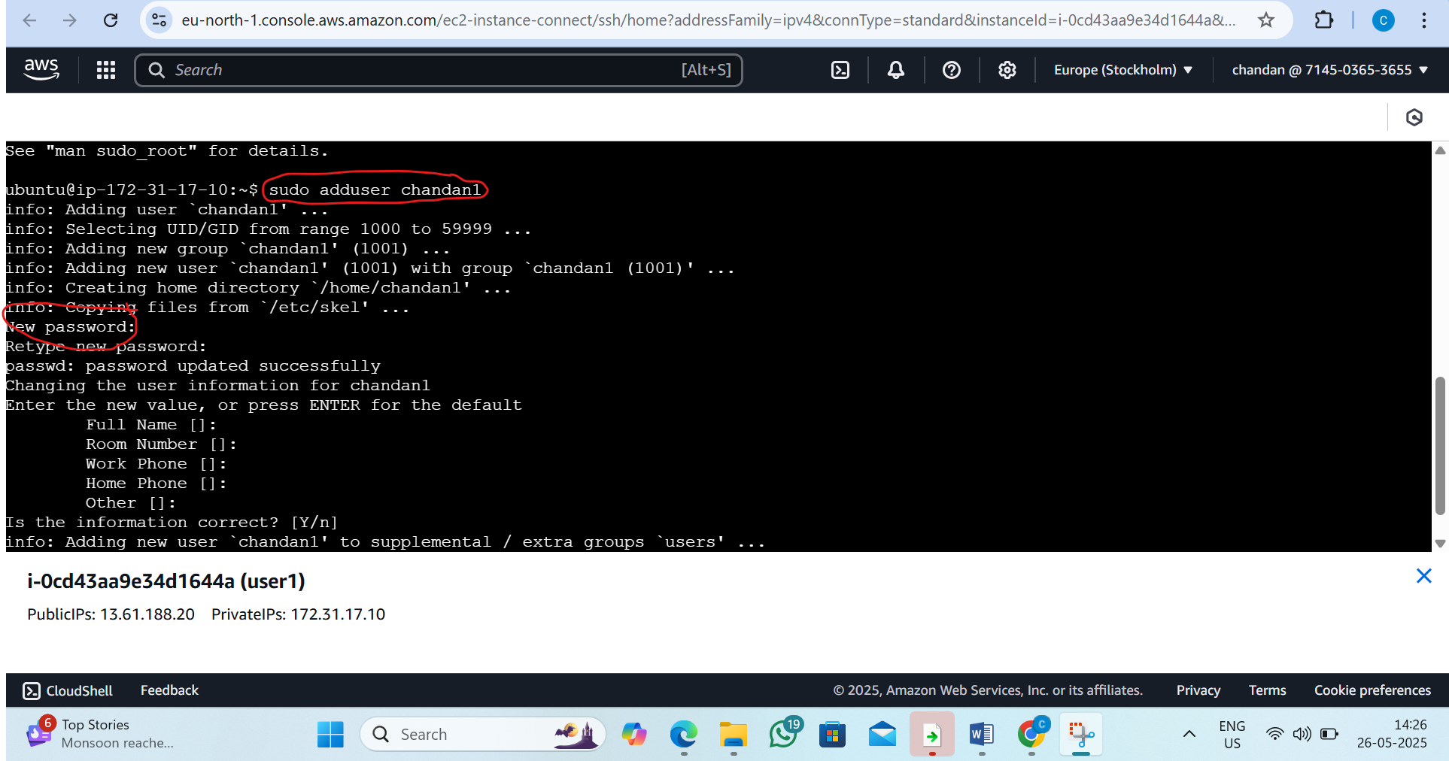
Step 4 :go inside the created user chandan1
By the command: su – chandan1
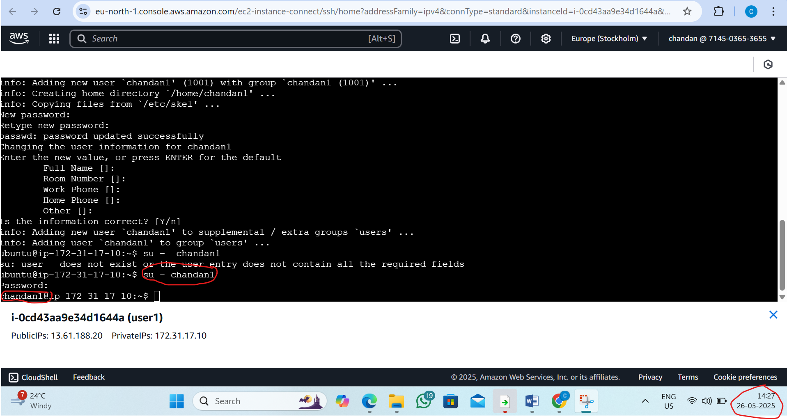

Step 5 : Now generate the ssh key
By the command: ssh-keygen
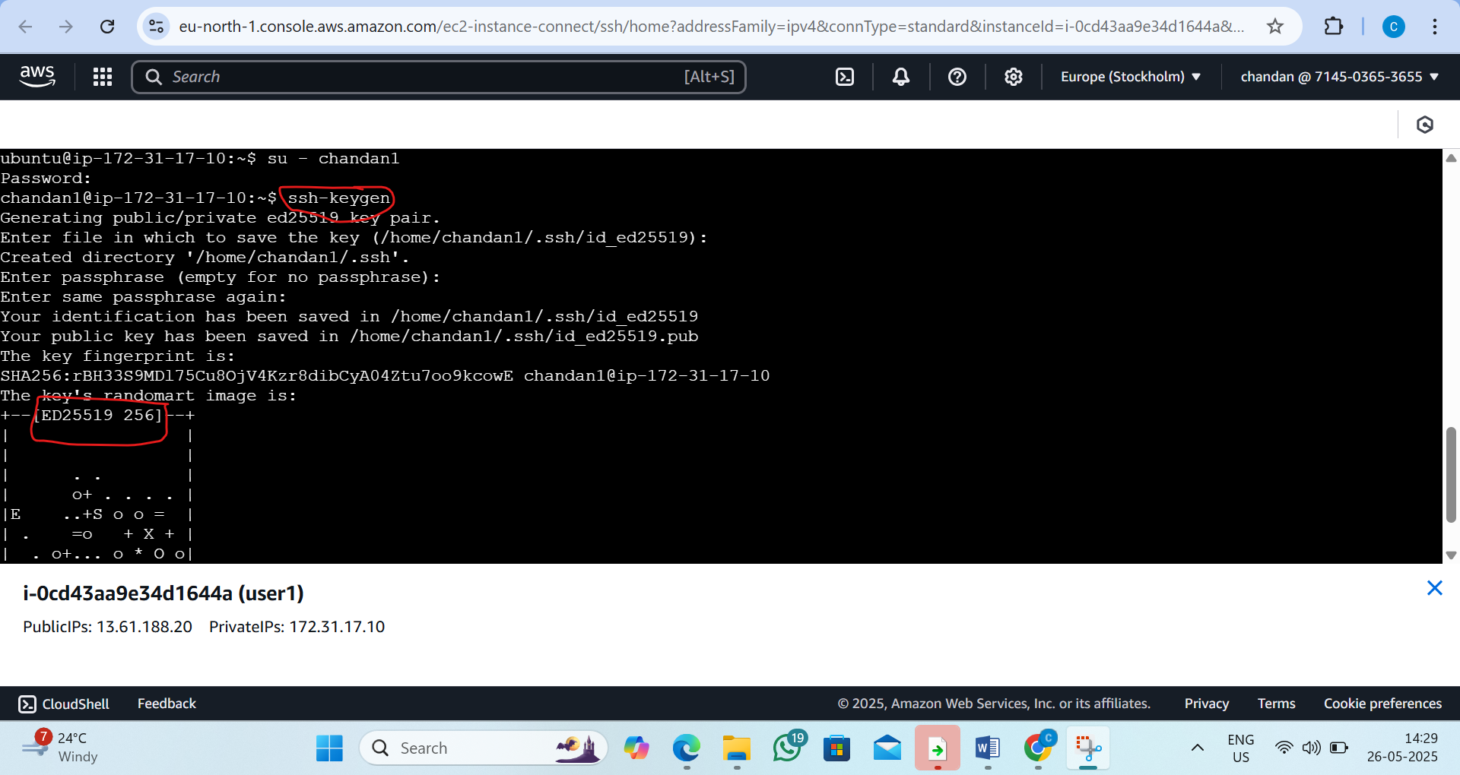

Step 6:go inside the ssh directory and read the key genarated
By the command:
1)ls -a 2)cd .ssh/ 3)ls -a 4) cat id_ed25519.pub
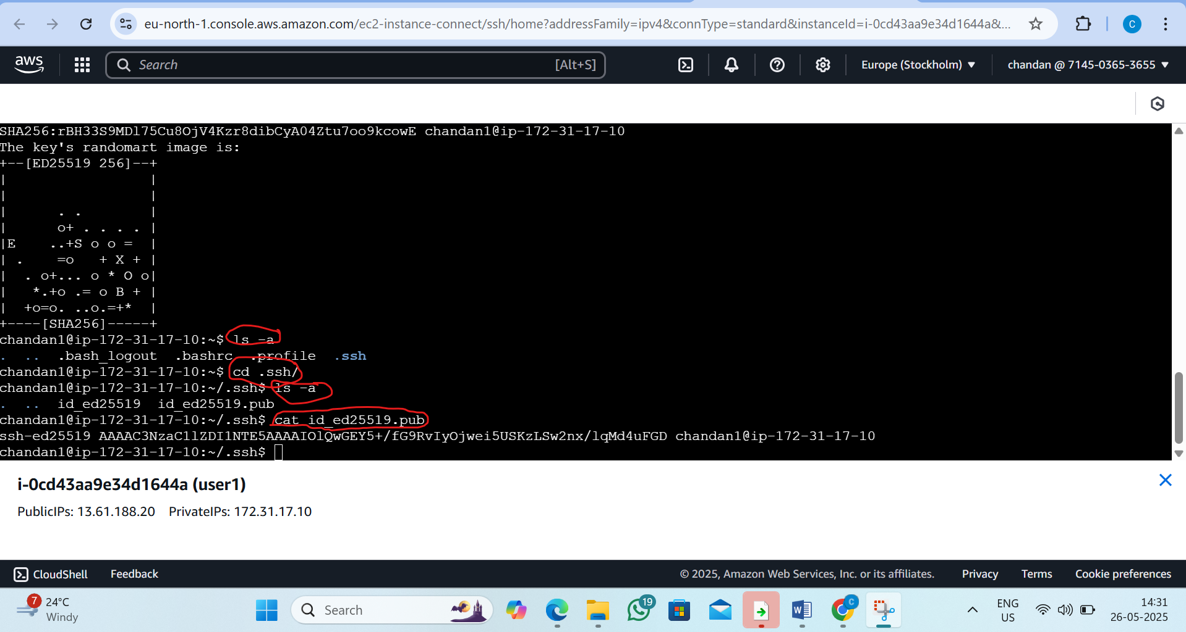
Step7 :now Connect user2 EC2 Ubuntu instance
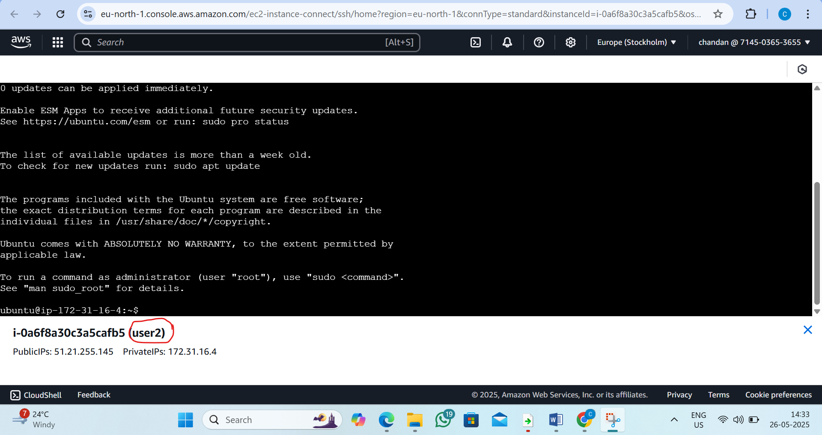

Step8 : we want add the user inside the user2 instance and create password
BY the command :_sudo adduser chandan2
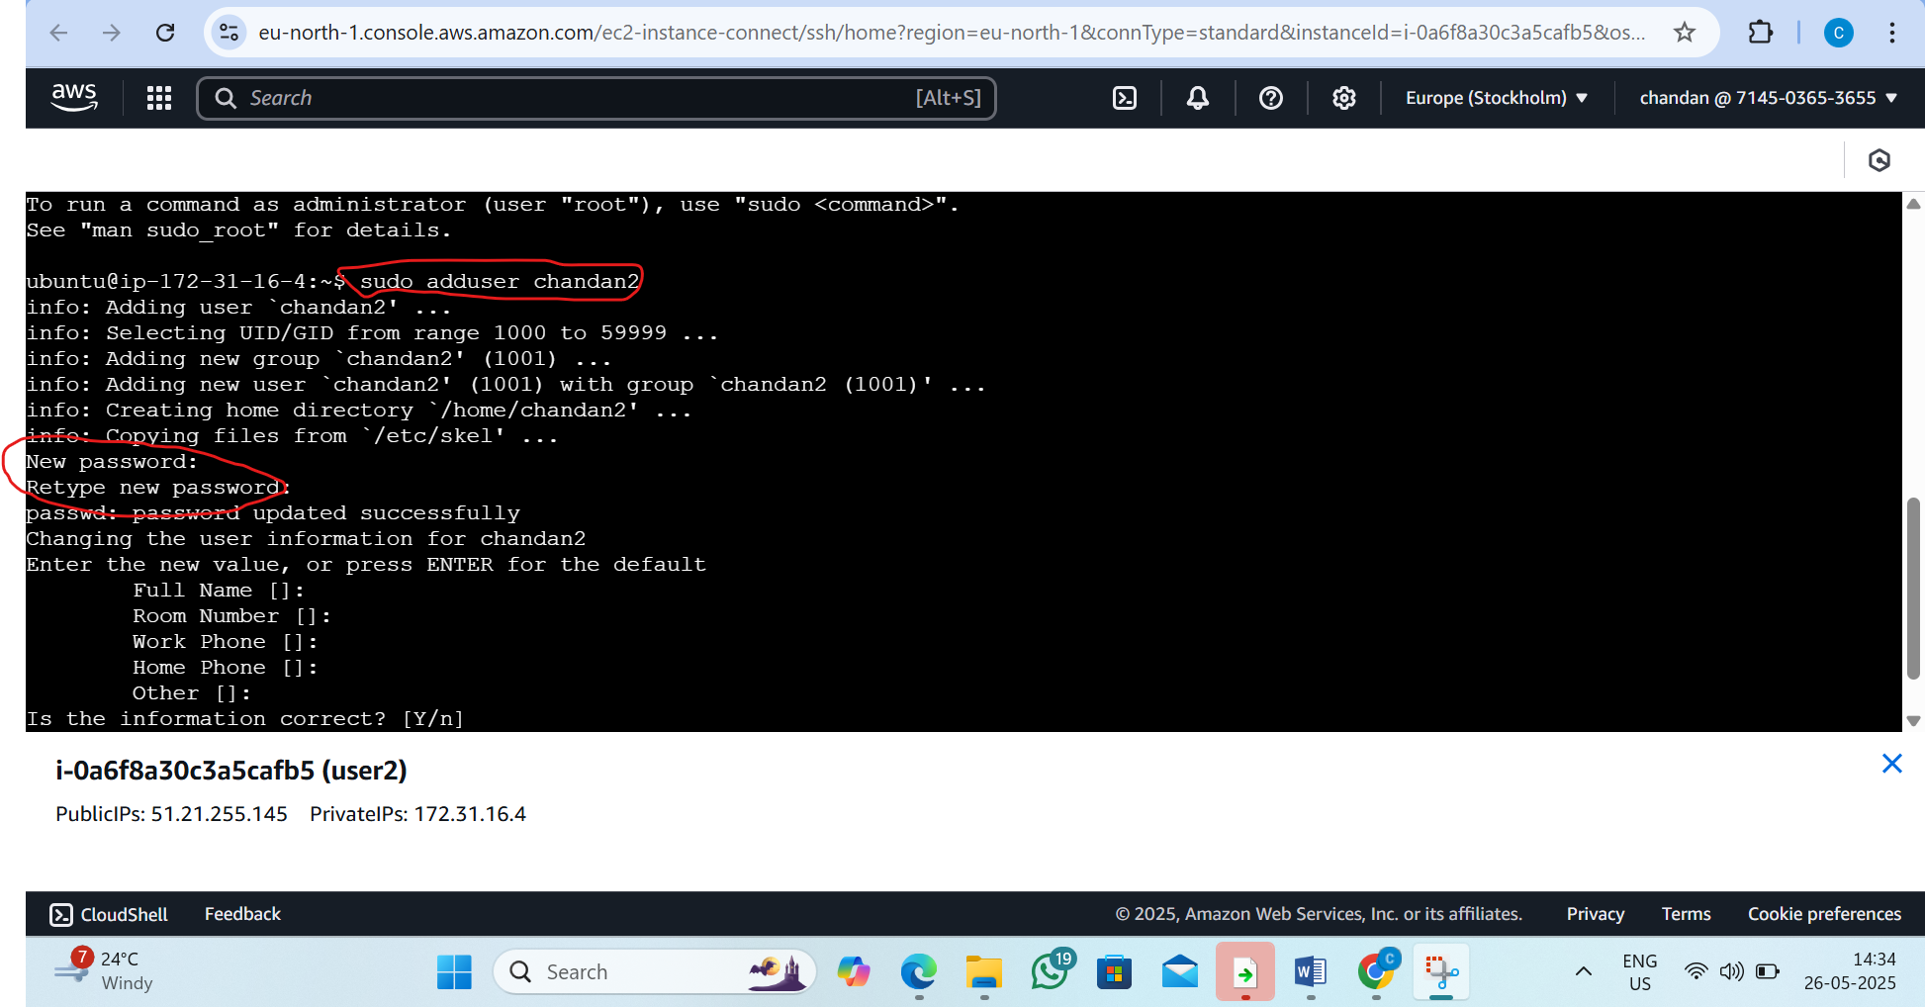

Step 9 : go inside the created user chandan2
By the command: su – chandan2
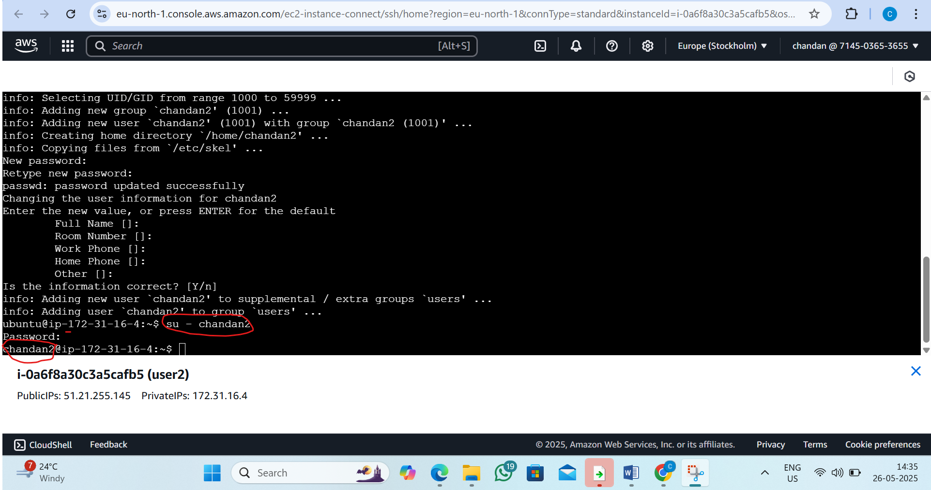

Step 10: make ssh directory and go inside the directory
By the command:1)mkdir .ssh , 2)cd .ssh/
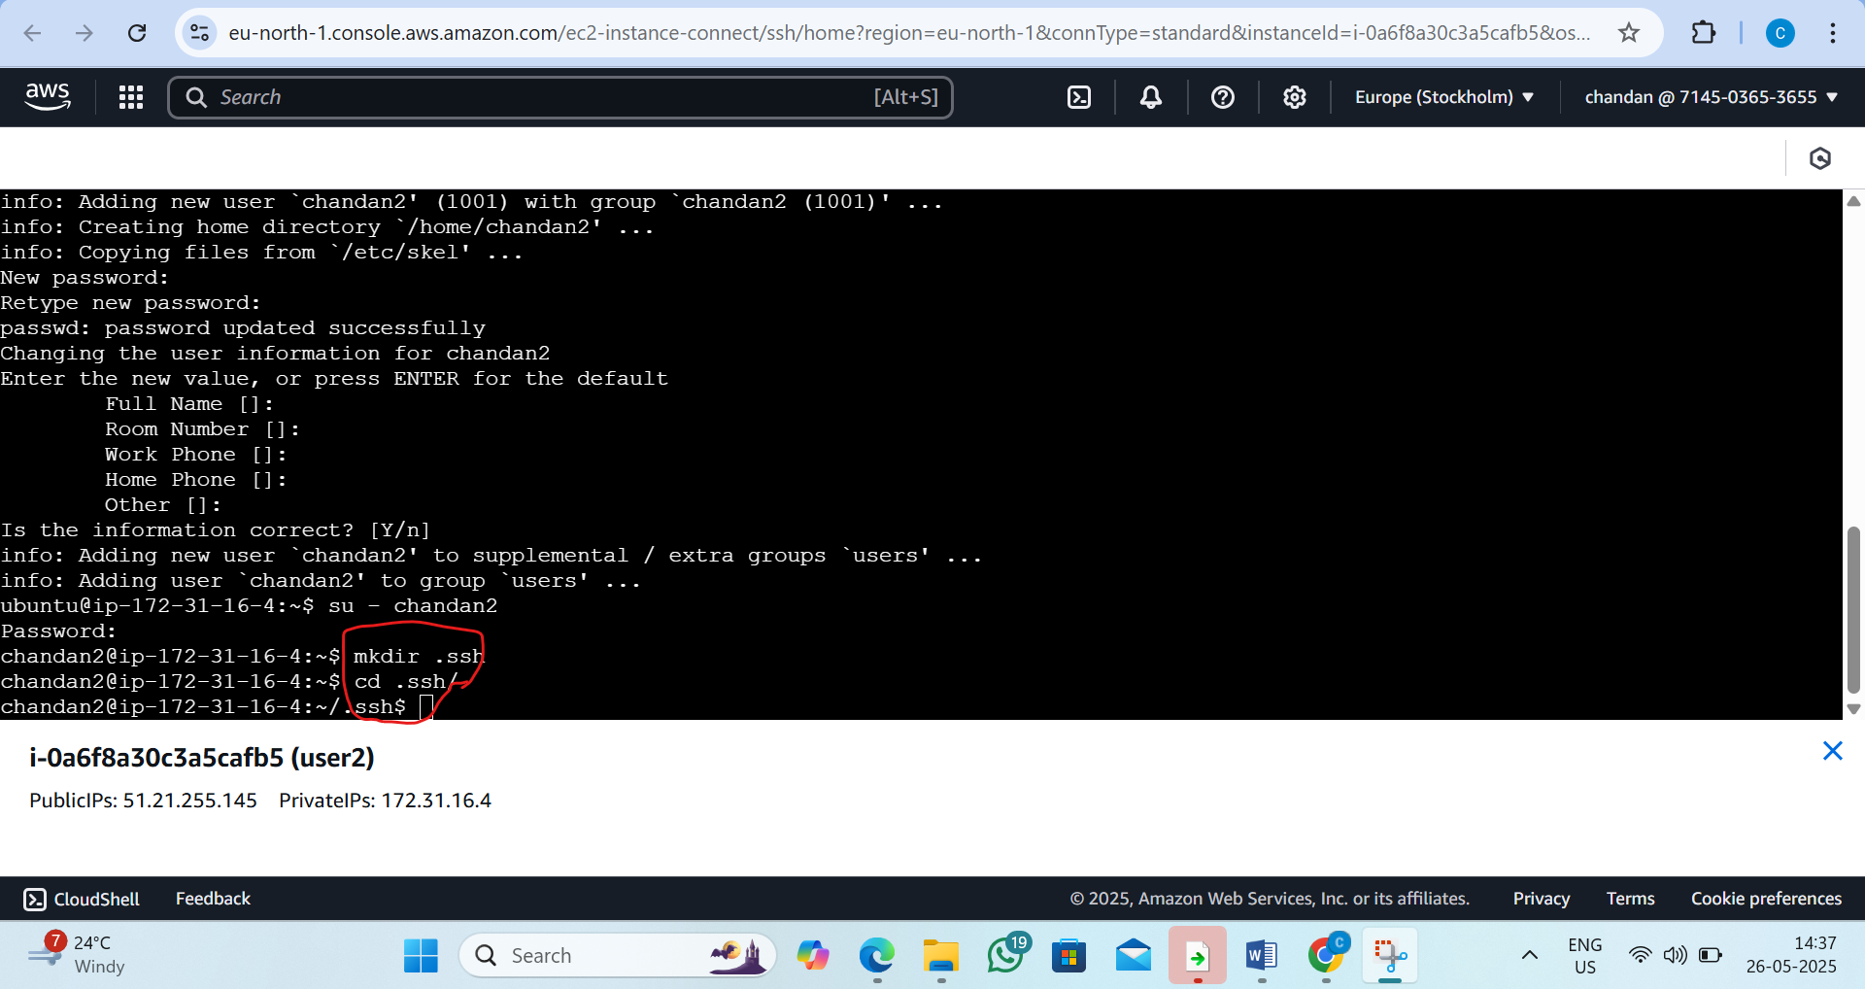

Step 11: now go inside the authorized keys by the vi editor
By the command : vi authorized_keys
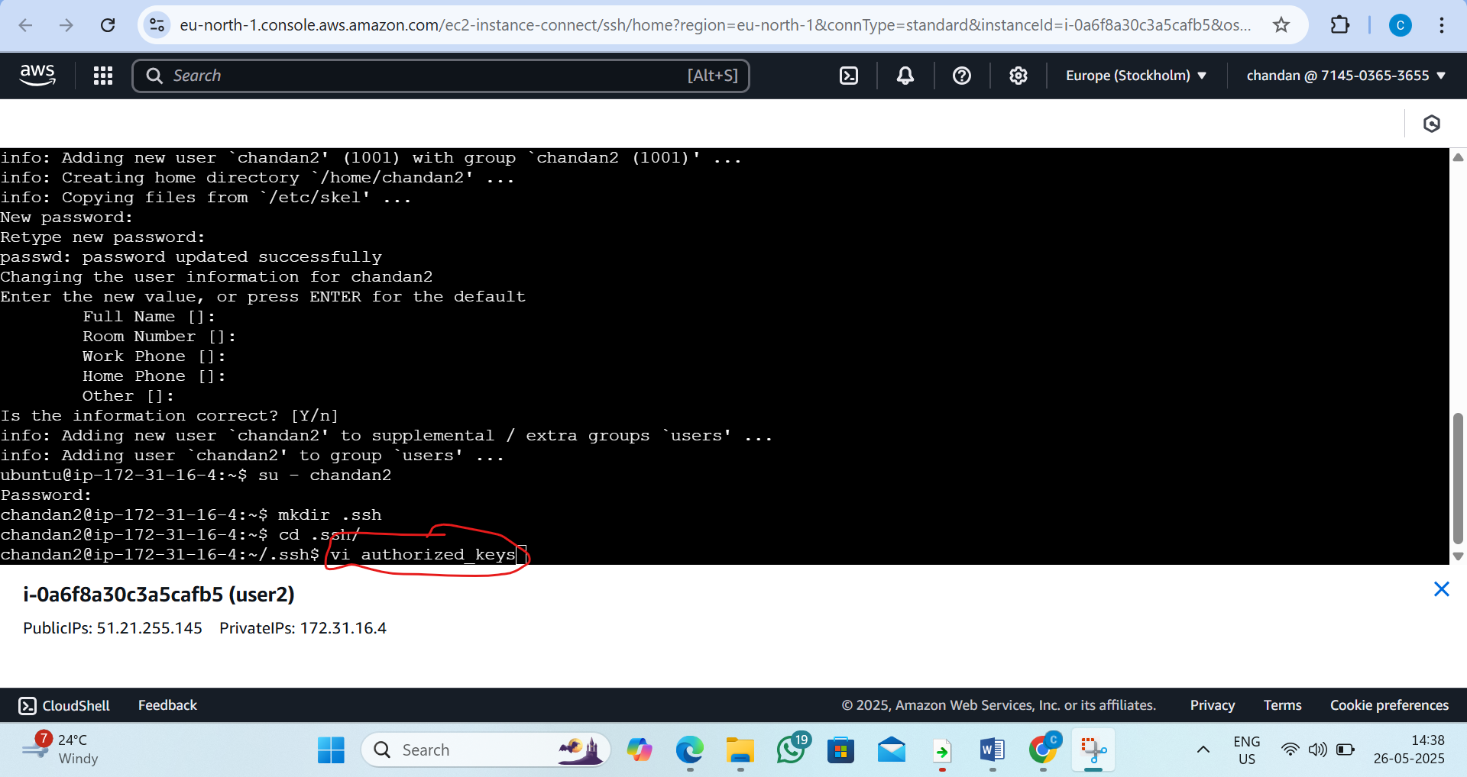
Step 12: now inside the authorized keys follow the following steps
1)press i 2) paste key generated by the user 1
3)press esc 4)type :wq and press enter
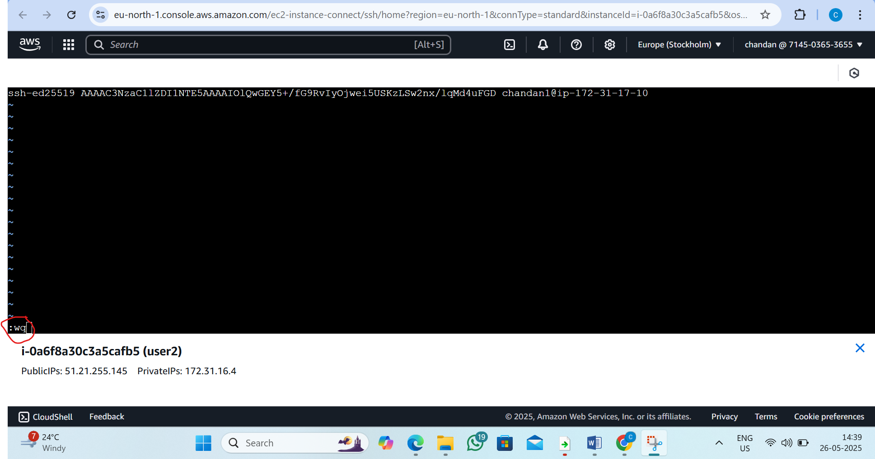
Step13 :copy the public ips in the user 2 and now go to user 1
Follow this steps
1)Pass the command:- ssh chandan2@paste the publicips of user 2(51.21.196.140)
Now overall command:-ssh chandan@51.21.196.140
2) type yes then the user1 can access the user 2
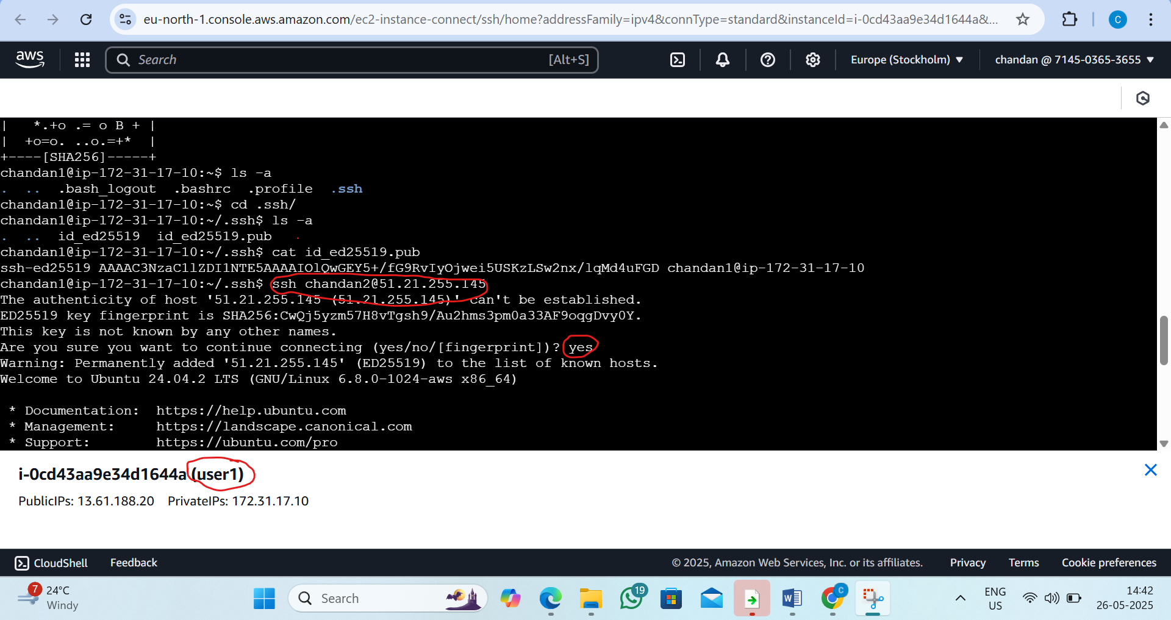
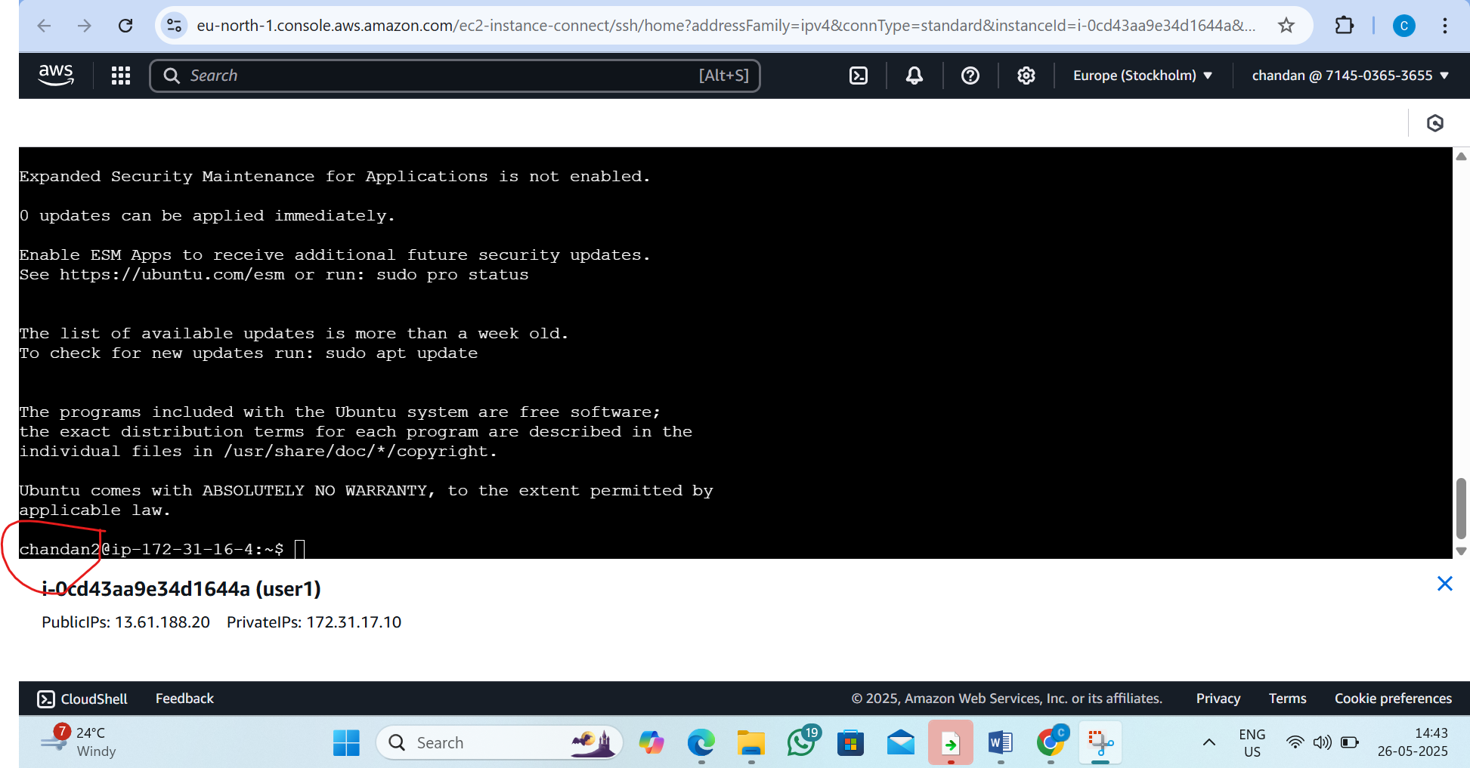
Step14:exit from the user1
By the command:exit
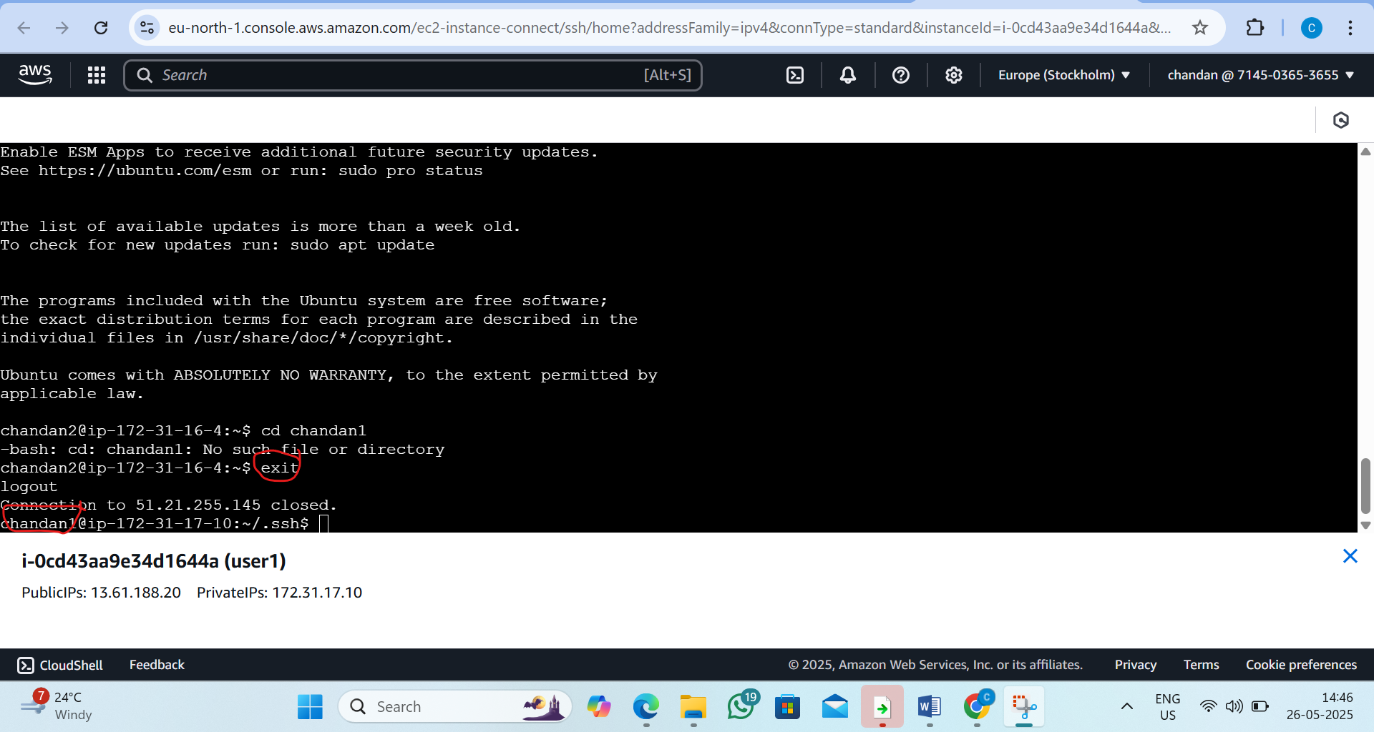
Step 15: Create a .sh File (parcel.sh)
By the command: vi parcel.sh
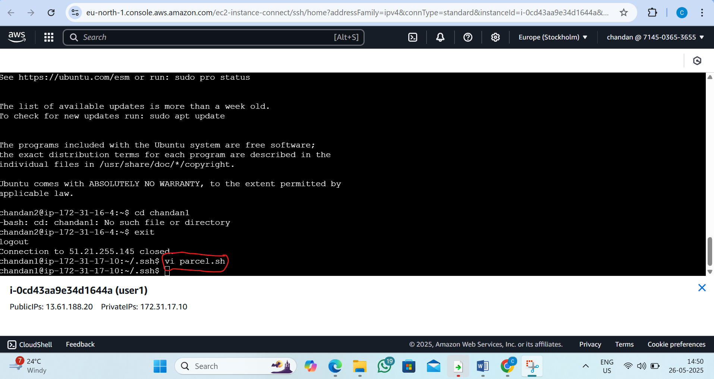

Step16:now follow the steps
1) Press i to go into insert mode
2) Type:echo "this is file for scp demo"
3) Press Esc
4) Type :wq and hit Enter (to write and quit)
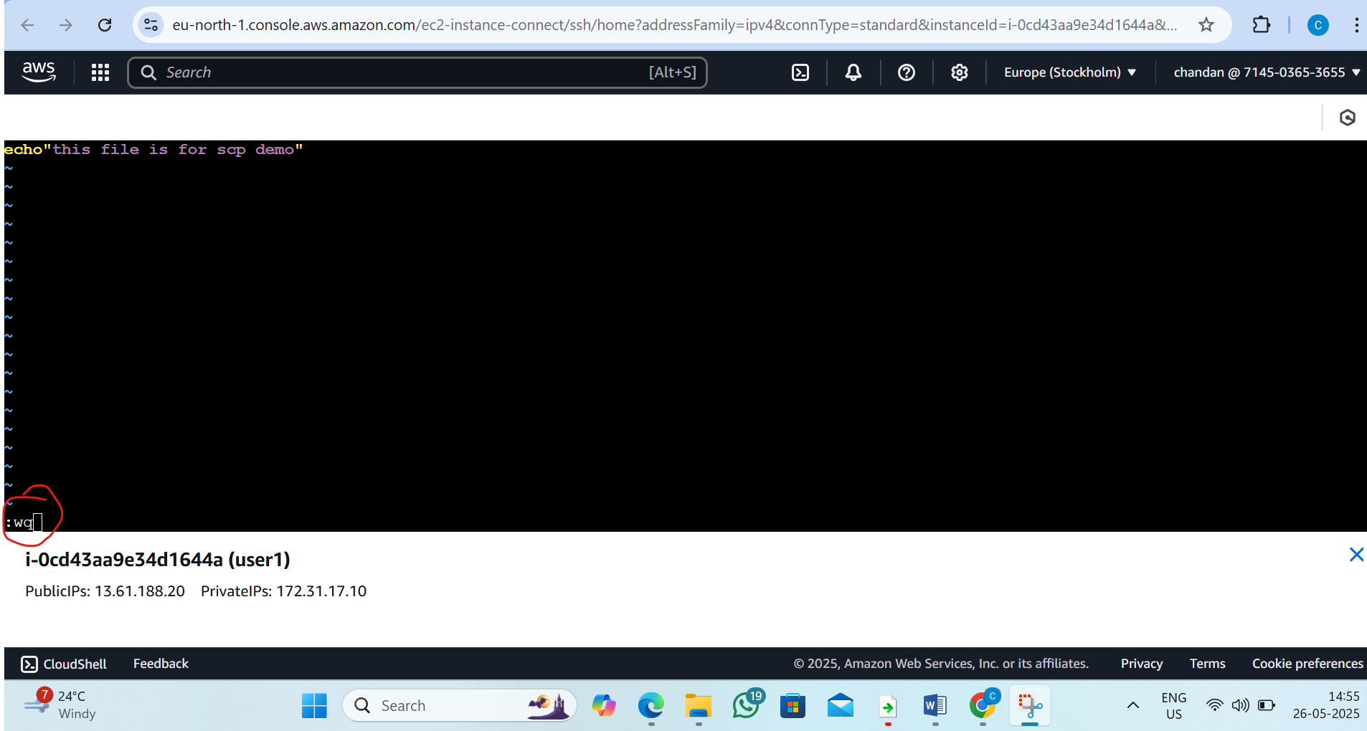
Step17:Now connect by pass the command
By the command:scp parcel.sh chandan2 @public ip of user2:/home/chandan2
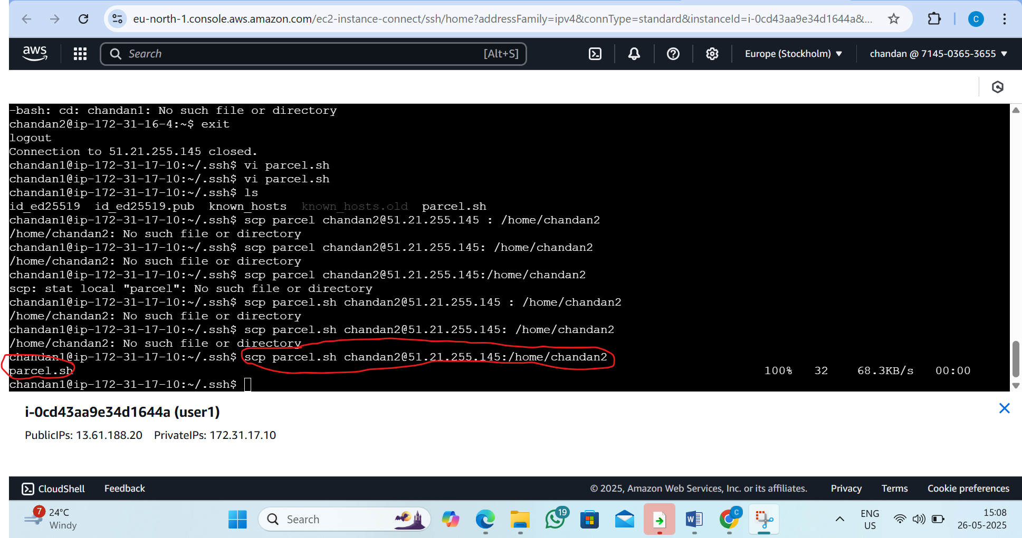
Step18:now in user2 ec2 ubantu instance verify parcel.sh can access
By command:ls -a
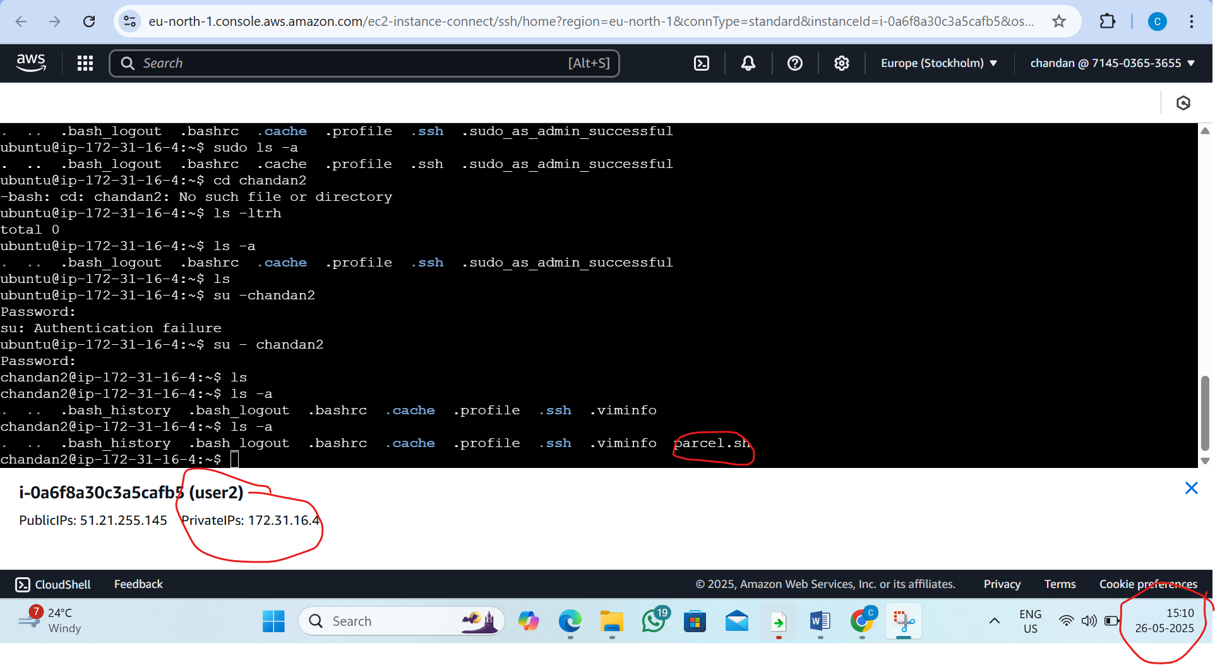

6. L6 - Write a Linux Shell Script to Install Git, JDK, Maven in EC2 Ubuntu Instance
Step1: Update the System
By command: sudo apt-get update
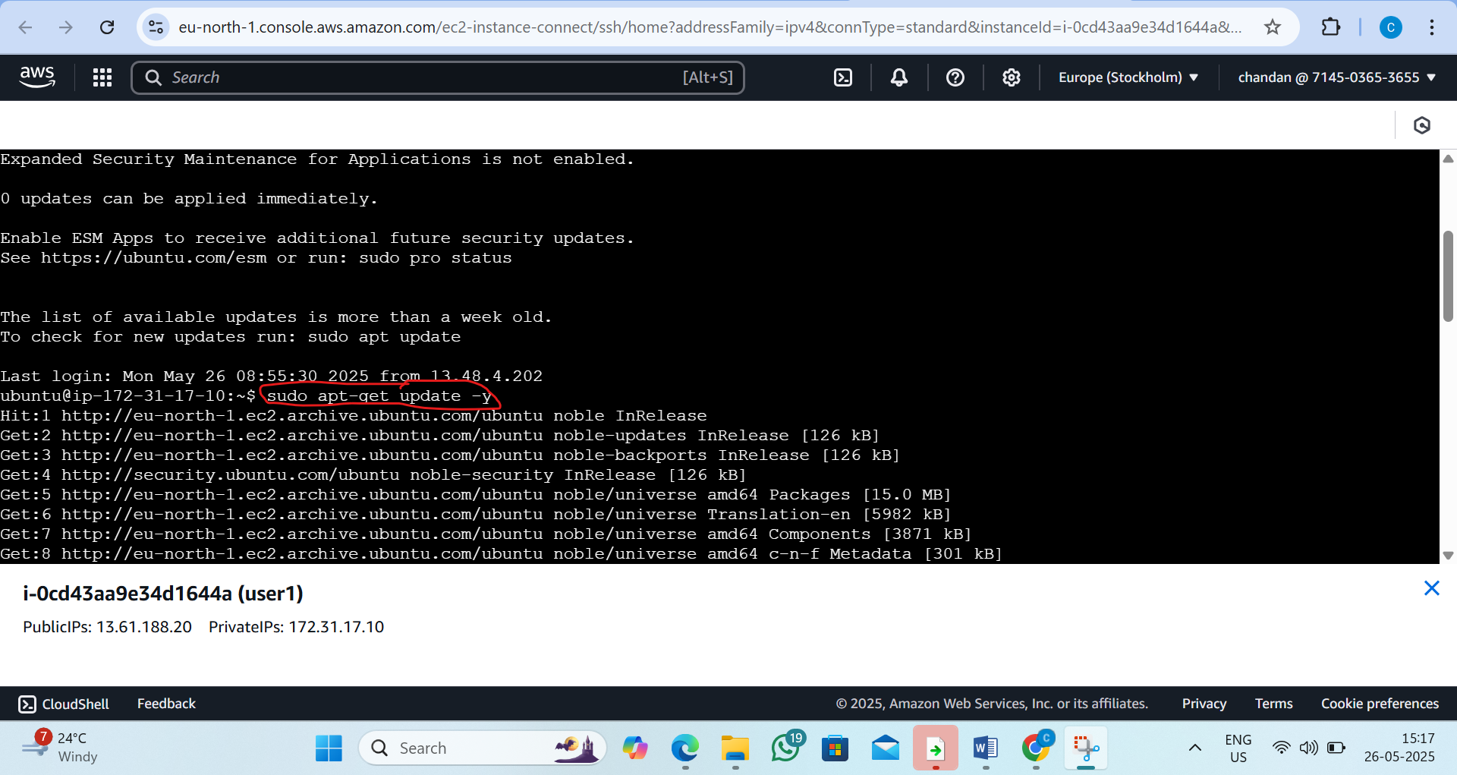
Step 2: Create a Shell Script Using vi
By the commend: vi install_dev_tools.sh
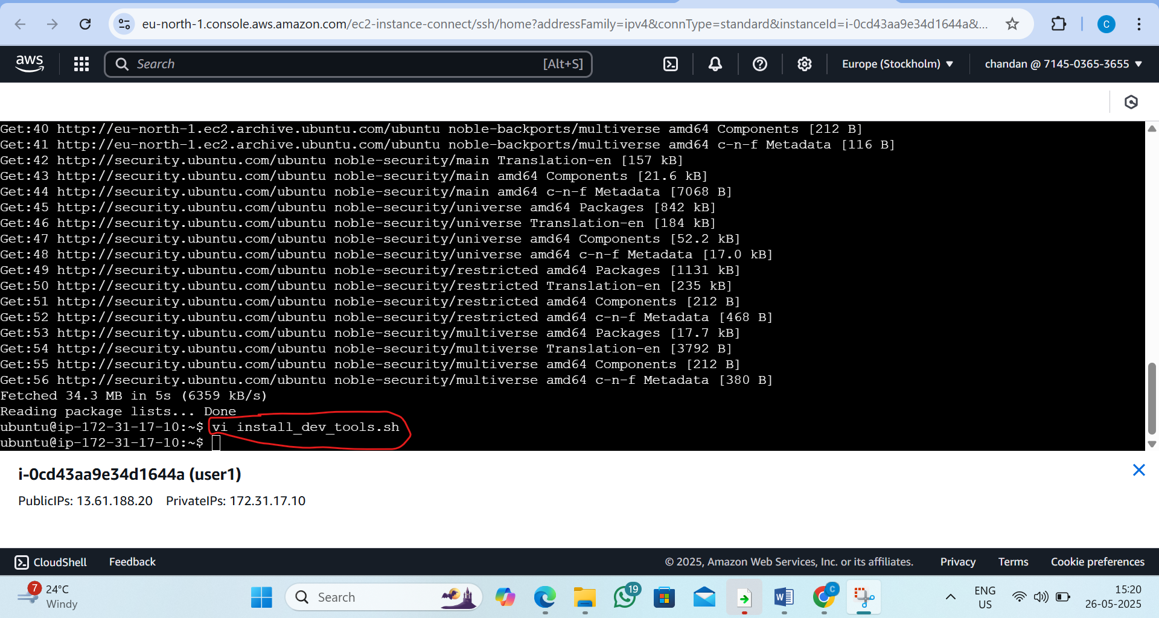

Step3 : Press i to Enter Insert Mode
Type this inside the shell
#!/bin/bash

# Update package lists
sudo apt-get update -y

# Install Git
echo "Installing Git..."
sudo apt-get install git -y

# Install OpenJDK 17
echo "Installing OpenJDK 17..."
sudo apt-get install openjdk-17-jdk -y

# Install Maven
echo "Installing Maven..."
sudo apt-get install maven -y

# Verify installations
echo "Installed Versions:"
git --version
java -version
mvn -version

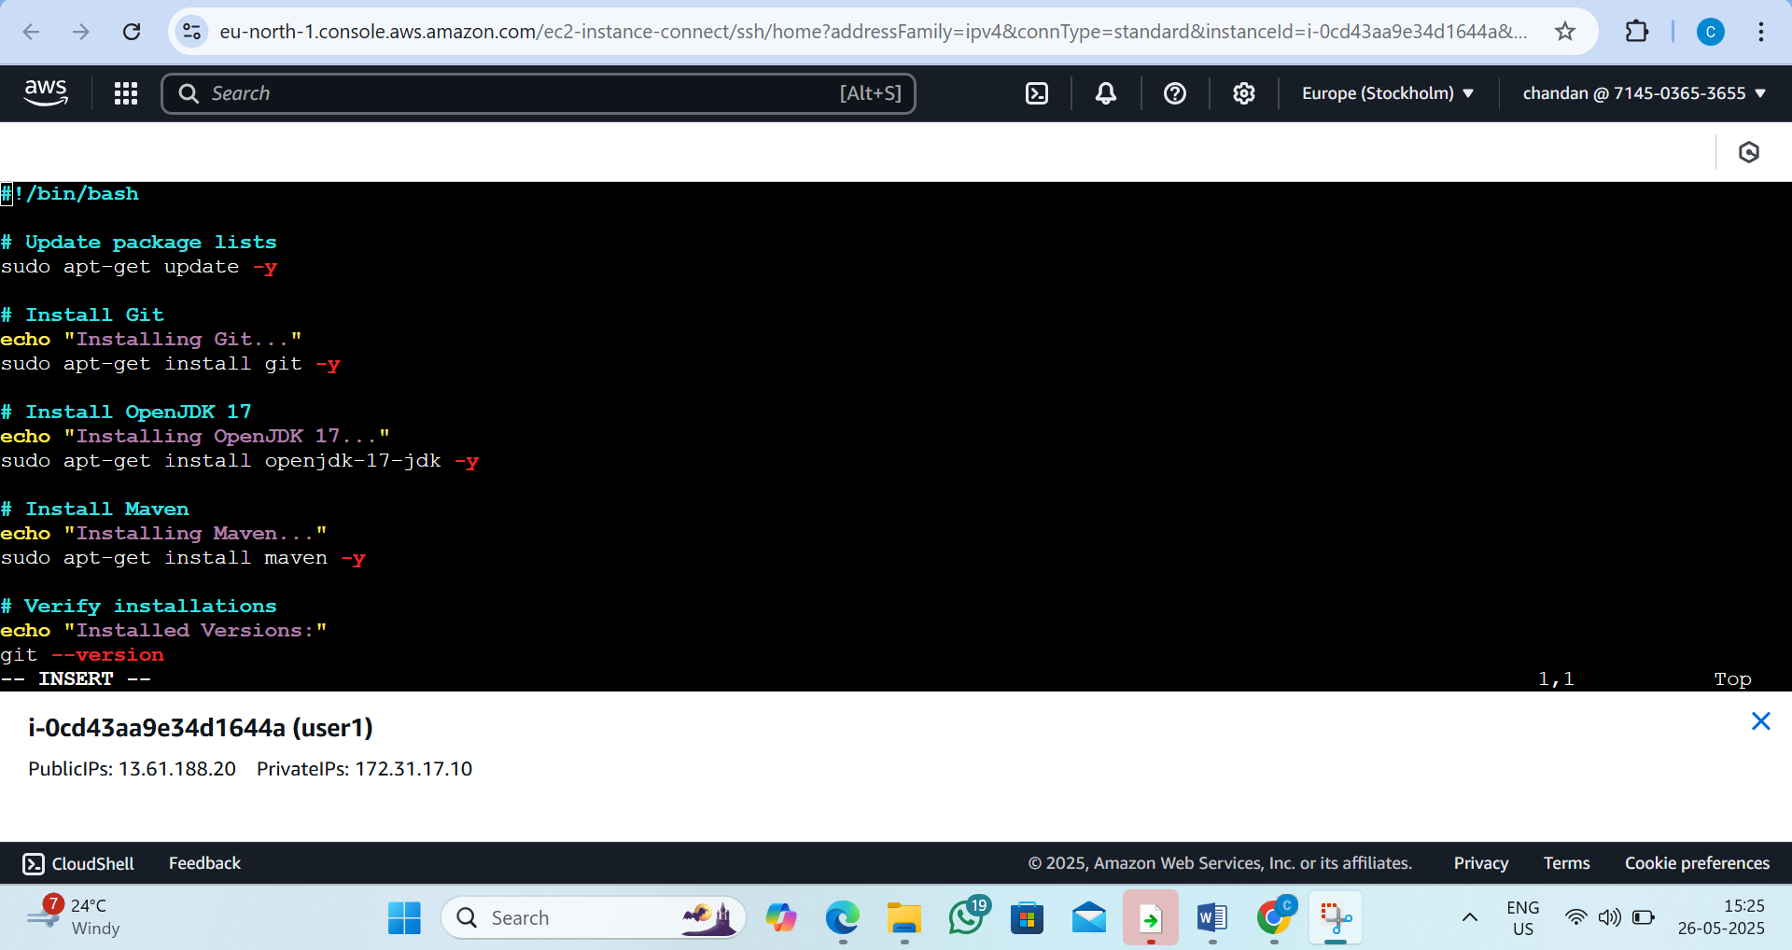

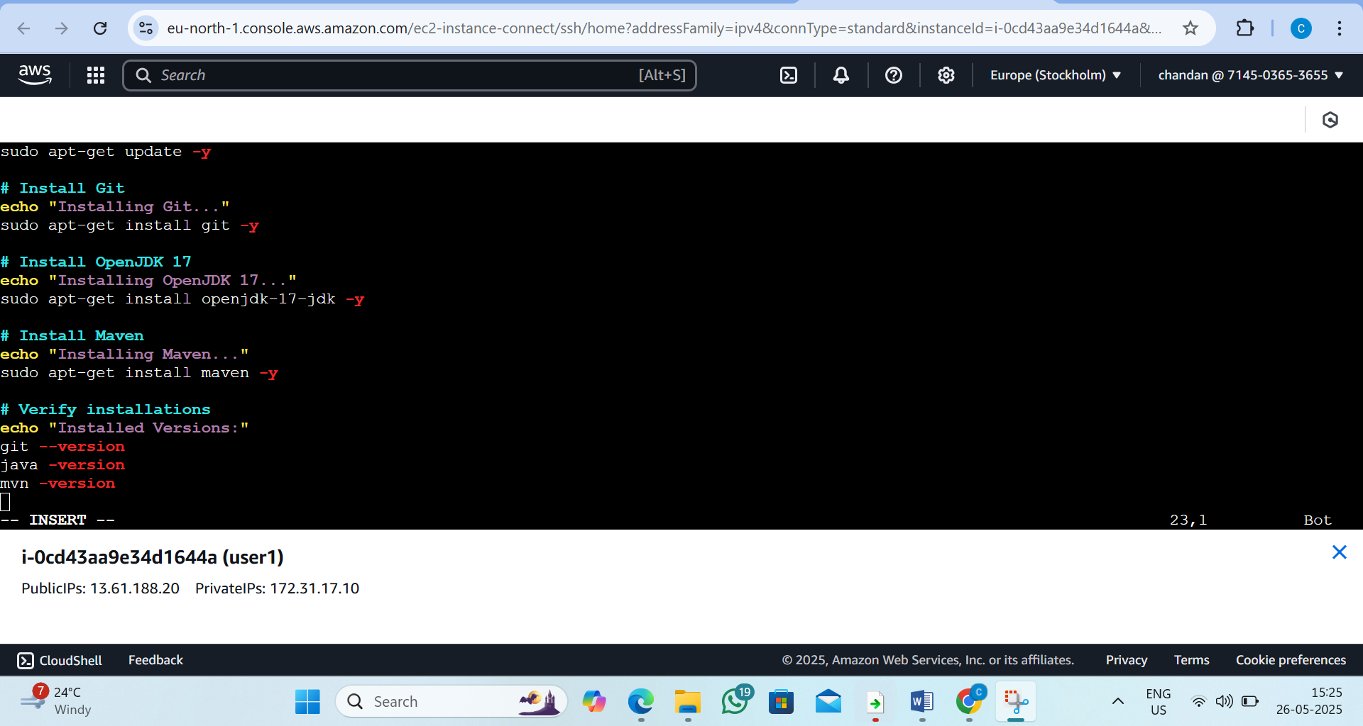

Step 4: Save and Exit vi
- Press Esc to exit insert mode.
- Type :wq and press Enter to save and quit.
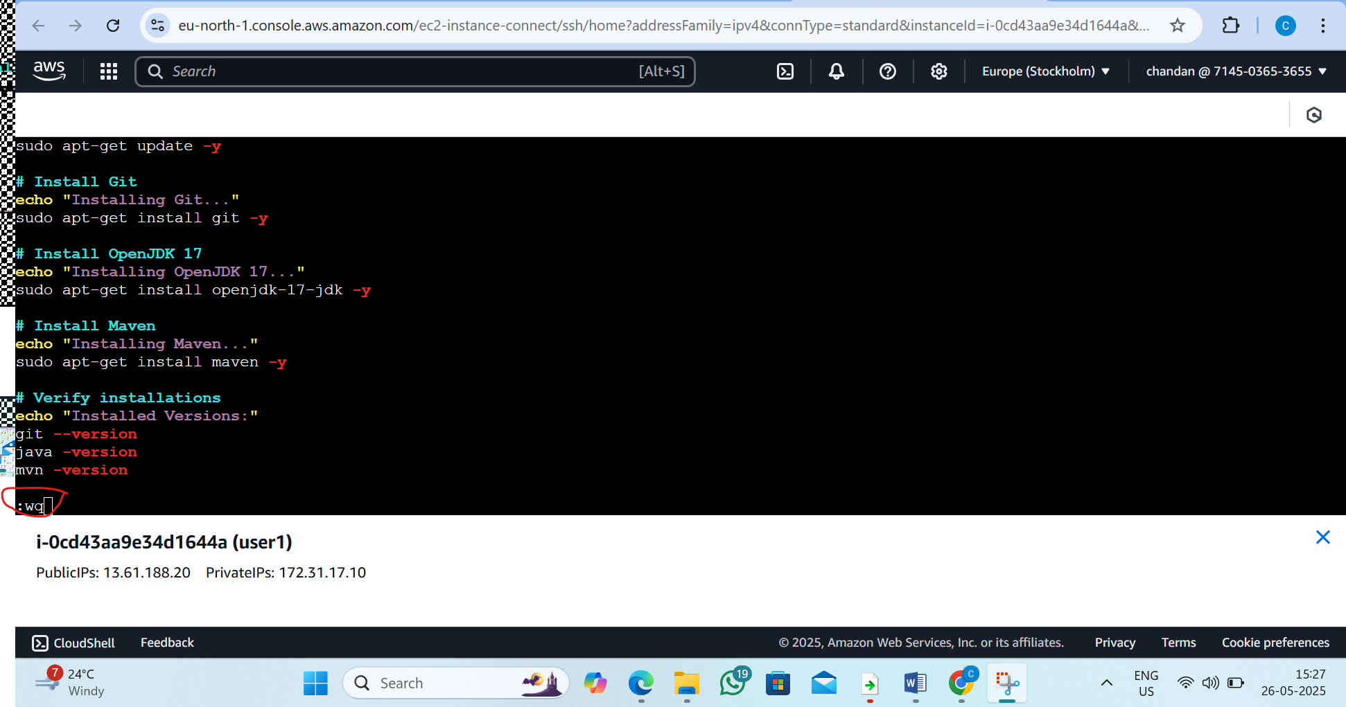

Step 5: Make the Script Executable
By the commend:chmod +x install_dev_tools.sh
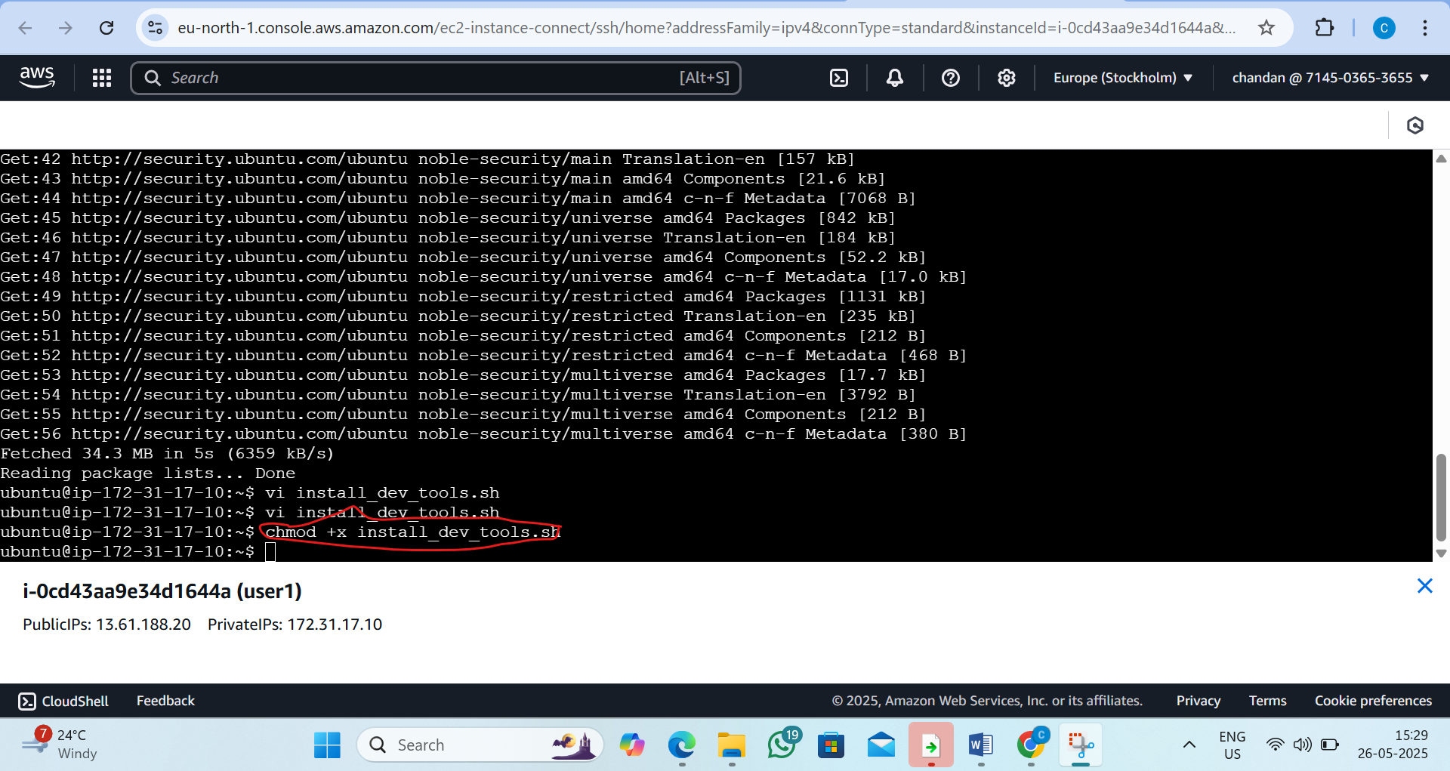

Step 6: Run the Script
By the commend:./install_dev_tools.sh
